THE EUROPEAN UNION AND BREXIT
Diana Maria Petcu, Romania, PhD in the third year at National School of Political and Administrative Studies SNSPA, 30A Exhibition Boulevard, 012244, Bucharest, RO
E-mail: petcu.diana95@yahoo.com
Abstract
The main objective of this paper is to find out the perception of the Romanians on this phenomenon and what are the consequences that the European Union imposes, what the effects of this phenomenon will be and how external relations between the two spheres will evolve. I decided to choose this issue because is a new phenomenon that the European Union has never faced before.
The main research hypothesis is this: what are the effects of leaving the UK and how is European foreign policy and society affected?
Over time it has been shown that the most effective way to resolve conflicts is communication. Regardless of the nature of conflicts, communication is the best solution, for this reason diplomacy is the key to all conflicts.
It was expected that after The United Kingdom leaves the European Union, there will be disputes and conflicts on several areas between European leaders: in the economic field, in the social field, in the field of security, etc.
It is known that the agreement between the EU and Britain has triggered several conflicts, but the purpose of the Agreement is to maintain peace. Thus, the rounds of negotiations and communication have diminished conflicts.

Keywords: Brexit, European Union, future

Introduction
It is interesting that over the years, Britain has been reluctant to make decisions taken by the European Union compared to the other Member States. Britain has refused to join the euro area and be part of the borderless movement area, the Schengen area, the aim being to work more closely together on international trade by both sides. Another important moment at the European level in which Britain did not participate was the signing of the Treaty of Lisbon in 2007, in which the former British Prime Minister of the time, Gordon Brown, was absent from the official ceremony. Until then, the former British prime minister did not have a clear vision of the future relationship between the United Kingdom and britain, his position being of reluctance and carelessness. The purpose of Treaty was to give the Union new powers, encouraging the participation of citizens in a new institutional order, in order to ensure a higher level of parliamentary control. The Treaty of Lisbon gave the EU legal personality and clarified the EU's competences. Interestingly, for the first time in the TEU, Article 50 is provided for, an official procedure that EU Member States must follow if they wish to withdraw from the EU. At the time, the Treaty of Lisbon was highly controversial in Britain, with eurosceptics asking Prime Minister Brown for a referendum on the new treaty.
The day of June 23, 2016 is the day when the future of the European Union and that of International Relations represents a real challenge, which will mark recent history at global level. 6 years after the start of this phenomenon, I am of the opinion that things have evolved in a direction in which the future of the EU is being called into question.
Even if Romania is not so concerned about this phenomenon, that of Brexit, indirectly we are affected, being European citizens. I say this because the UK is a strategic partner at the European level, and maintaining close ties with this state is fundamental to national security, even after the Brexit process is completed. We all know that the process and procedure for the United Kingdom's exit from the European Union has not been an easy one, as there have been numerous conflicts over the four years of negotiations. The fact is that the vote of the British citizens influenced the future of the entire British people, but especially of the European Union, implicitly also of the Romanians. I believe that the UK's decision to leave the EU also came in a tone of manipulation of the population on the part of the British political parties that supported this move. I do not believe that leaving is a solution for the British people, but neither is it for the European Union.
For this reason, I support the fact that the future of the European Union is difficult to predict, as there are many obstacles encountered: from the Brexit phenomenon to the Covid-19 pandemic, then the Ukraine-Russia war.

Globalization
Did the phenomenon of globalization contribute to all these phenomena? As we well know, the project of globalization continues to improve the living and living conditions of the population, through the constant development of international trade, digitalization, the reduction of conflicts, the encouragement of cultural diversity, etc. The European Central Bank defines globalisation as a phenomenon that has transformed the economy: we can order online, we can deliver products around the world, and competition between countries has increased.
Taking into account the fact that there was no international context for a Member State of the European Union to leave the European sphere, the future of the European states will be affected, and the development of the process of withdrawal of the United Kingdom of Great Britain will bring consequences. Many question marks will arise and will persist for a long time, and both parties have learned to negotiate and treat the phenomenon with maturity, so that in the end there is an advantage for both partners and the collaboration is a peaceful, productive one. Any regulation issued by the EU has an effect on any member state, and as the UK is no longer part of the 28 member states, there has also been a legal impact, and the common European space has also been affected. Since the break-up, numerous laws have been passed by the British Parliament on the application of the European Directives, with small amendments and negotiations on this subject. But, nevertheless, the UK is no longer a member of the EU, and these European regulations no longer make sense, but there are consequences and other areas are affected.

Effects of Brexit
Another branch affected by the effects of Brexit is the P.E.S.C (Common Foreign Security Policy), with The United Kingdom being an important military power at the European level. Thus, the field of security and defense was slightly affected after the withdrawal of the United Kingdom from the common space, having the concrete example: the Russia-Ukraine conflict, which directly affected the European Union as well. Certainly, the UK's exit from the EU was an important factor in the destabilization of European security, regarding the economic, political and inter-human instability installed at European level after Brexit, but especially after the pandemic crisis caused by the SARS-COV2 virus. Another factor that leads me to believe that this branch has been affected by Brexit is that of the outbreak of war, which has endangered the external security of the EU. However, I can say that the war was also an opportunity to bring the Member States closer together and unite, because they showed solidarity and supported Ukraine, with progress in the area of European integration and the possible accession of Ukraine to the EU.
Globally, the United Kingdom was an important financial player, having a great economic power and influence in the European Union, and statistics from 2020 showed that the British contributed a value of 17.07% to the European budget, after Germany (total contribution of 28,064%) and France (23.68%).

Case study – Romanians' perception of the Brexit phenomenon
Methodology
In order to answer some of my questions and to be able to have some convictions regarding the Romanians' perception of Brexit and in order to achieve the objective (to carry out an investigation based on the questionnaire), I applied a questionnaire among Romanian citizens. He had structured, but also open questions, with variants of answer, in order to be able to measure the Romanians' perception regarding the exit of the United Kingdom of Great Britain from the European Union. The results were quantitative and the data processed were through the statistical method. The goal was to measure and obtain various information dedicated to the perception and influence of Romanians regarding this new phenomenon.
The questionnaire was conducted in the online environment, and the 208 respondents were randomly chosen, from all age categories, different working fields, in order for the sample to be correctly validated. For this reason we wanted the subjects to be of different ages, to be from both categories of sex, but especially from different fields. The data were interpreted both statistically and psychologically, paying special attention to the data obtained and correctly interpreted.

Demographic data
Thus, my case study was conducted based on a questionnaire designed and started between May 23 and June 1, 2022, including in the study group a number of 208 subjects. As can be noted below, most of the subjects 40.9% fall into the age category 26-35 years, the next age category is that of 15-25 years (36.1%), the third position being occupied by subjects aged 36-50 years (18.3%), and only 4.8% are over 50 years old. Regarding the gender distribution of the subjects included in this study, 131 were female (63%) and 77 male (37%).
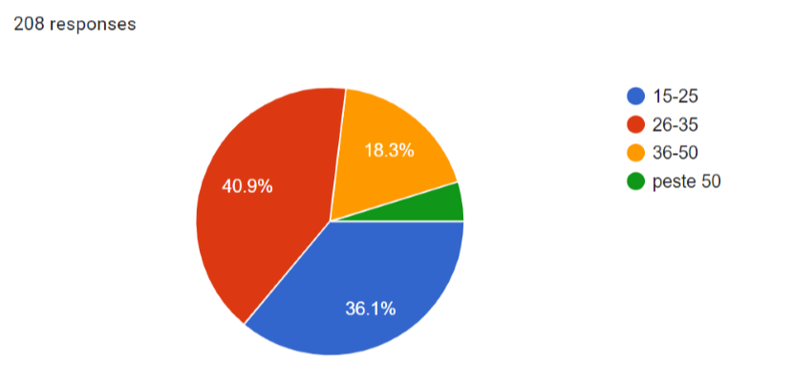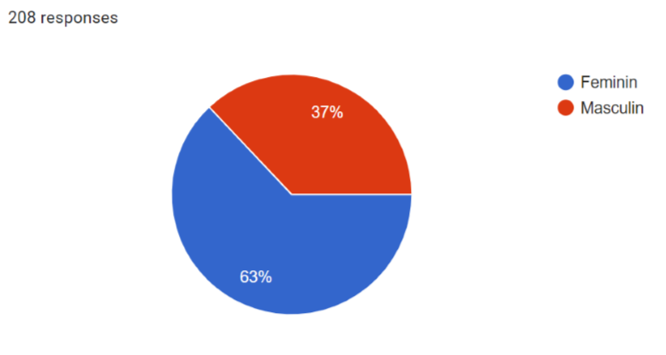Fig.1Fig.2

Regarding the marital status, it can be easily noticed that most subjects are single: 151 respondents out of 208 are unmarried (72.6%), in the second position are those married with a percentage of 22.6% (47 subjects), and the remaining 5% are divorced or in a relationship. Regarding the provenance environment, 79.8% (166 respondents) are from the urban area, and 20.2% (42 respondents) from the rural area.
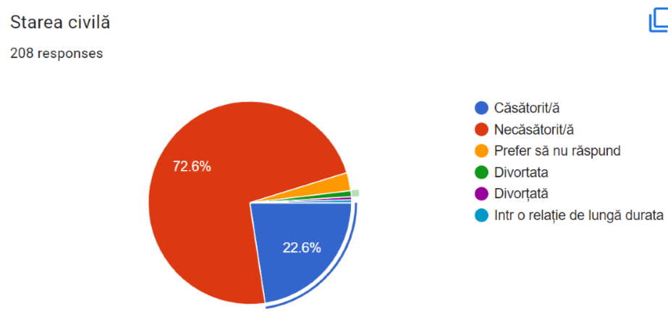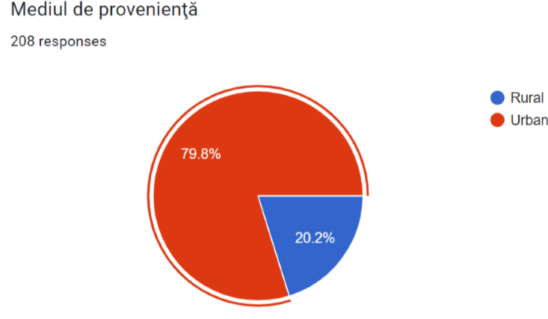
Fig.3 Fig.4
It is worth noting that the level of study of the respondents is diversified, in the sense that 32.7% hold bachelor's degree, 28.8% hold master's degree, 18.3% high school studies, 14.4% post-graduate studies, 4.3% secondary education, and 1.5% others. As for the socio-professional category, 44.7% are employed, 20.7% are unemployed students, 17.8% are students with a job, 13.9% are entrepreneurs, and 3% are others.
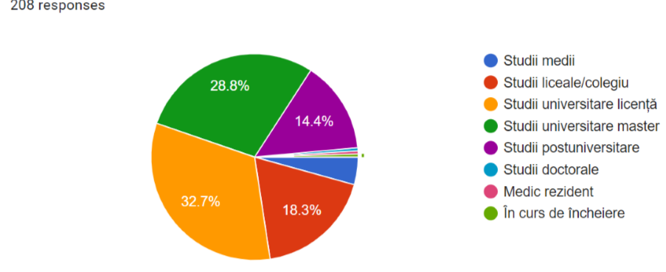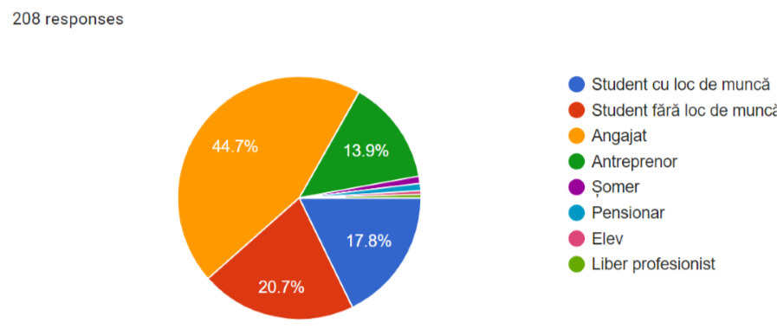
Fig.5 Fig.6
Interestingly, to the question "Have you heard of Brexit? ", most of them chose the yes answer option, 98.6% of respondents, while 1.4% have not heard of this phenomenon, but 82% know the details of Brexit, and 17.3% do not have detailed knowledge of this phenomenon.
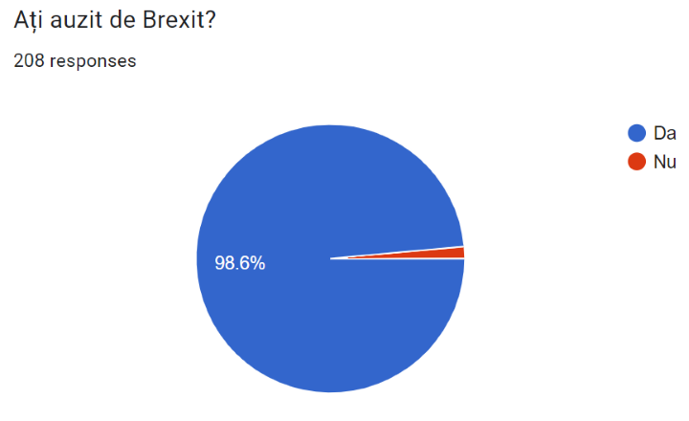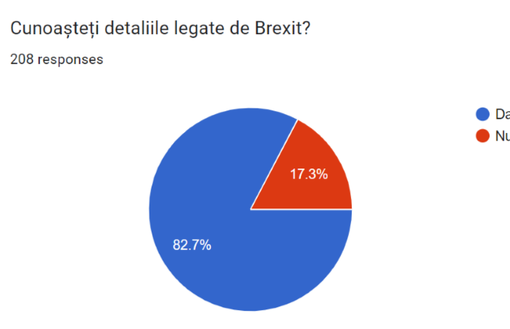Fig.7Fig.8
As can be seen, more than a third of the total number of respondents have information about the UK's exit from the European Union. Respondents were also asked if they had viewed the movie Brexit: The Uncivil War, which reflects the exact reality: 89.4% did not see the film, and 10.6% of respondents saw it. One interesting thing is that this film is an important detail, it certainly represents reality, based on real facts, it is not a documentary.

Pro vs against Brexit
Going to the next question, more than half of the respondents disagree with Brexit, as can be seen from the image below, 124 out of 208 subjects expressed their vote that they do not agree with Brexit (59.6%), while 84 of them agree with this phenomenon (40.4%).
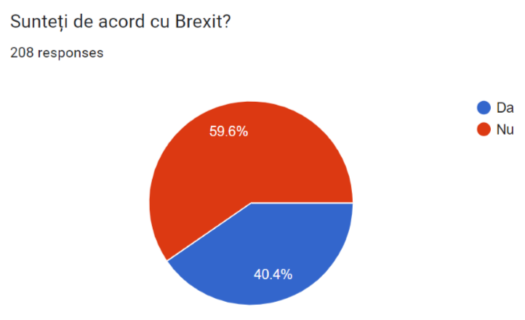
Fig.9
To the next question, the subjects had to argue their chosen decision above, and the answers were diversified, and those who agreed to Brexit (40.4%) reasoned otherwise: " I agree because it is a free choice that people make." " The right of any state to choose what is best for it. "; " Yes, because every country wants its own independence and power. " I believe that a country's desire for independence cannot be disputed." It's a national decision." "If the state in question considered that this measure is to their advantage, if they have seen more positive points in this, it is their right to choose. " "Any State should be economically independent."; "Yes, because the European Union is far too unstable for a country like Britain"; "Uncertain future , discrimination, no easy access to the European single market"; " Yes, if they chose that way, I don't see why I would judge them. It is their decision and it must be respected", "It is the choice of the UK citizens, it is not my choice"; " I believe that every country should leave the EU and develop on its own. Let's not depend on anyone anymore." .
Those who disagree with this phenomenon (59.6%) argued as follows: "No, I do not agree, because the repercussions are felt by all people european citizens"; "No, because the consequences are being felt for citizens, both in the EU and in the UK."; "The European Union is stronger when members are in collective harmony. If a member leaves, it means that there are problems internally and adapting the Union in as short a time as possible is critical. Also, as a result of Brexit, a considerable number of workers in various fields coming from other countries have lost their jobs/ right to stay in the UK. This explains the acute labour shortage and the recent food and service crises in the UK." The European Union offers many advantages to the component countries, and the UK's exit from the EU has affected many citizens. It makes the process of travelling to the UK more difficult. The EU loses an important member."; "Consider that it is not an advantage for the UK, because it hinders stability, the economy, has weakened the image of the EU"; "I do not agree because the citizens have made these decisions without knowing the consequences, and there are several states involved that lose economically, politically socially, etc." .
It seems that the economic, political and social instability has been noted by the Romanian citizens regarding the effects and consequences of Brexit, and the decision of the United Kingdom to leave the EU is respected by the Romanians, without judging the election of the British, considering that each country has the right to decide and choose what is best for it.

Policy area
From a political point of view, on a scale from 1 to 5, where 1 means to a very small extent, and 5 means to a very large extent, the Romanian respondents are of the opinion that there will be consequences, as follows:
- 1 (to a very small extent) – 5.8%,
- 2 – 12.5%,
- 3 – 32.2%,
- 4 – 30.3%,
- 5 (to a very large extent) – 19.2%.
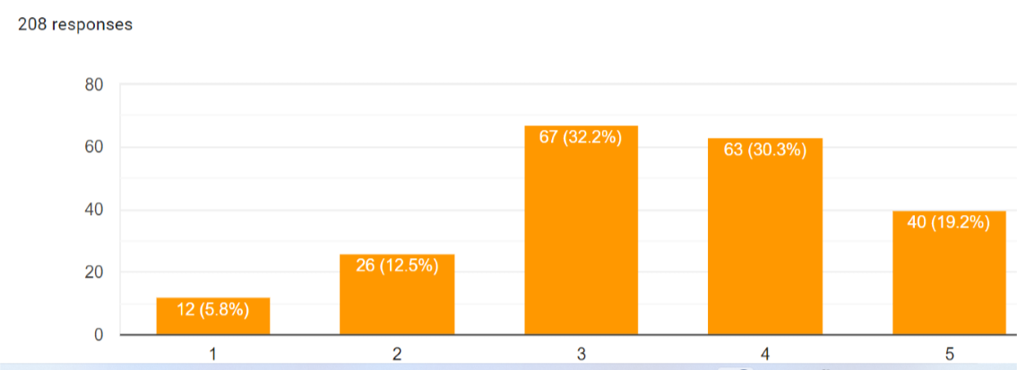
Fig.10

Economic area
From an economic point of view, trade between the two parties has been reduced. Onthe fact that Britain's exit from the bloc has brought with it economic disadvantages for the United Kingdom, it has hampered international trade and transport. If we refer to Romania, we will see that Romanian citizens are sceptical about the economic field, with consequences. Thus, a fairly large percentage of the people included in the study group of the present research shows that on a scale from 1 to 5, where 1 means to a very small extent, and 5 means to a very large extent, the economy is affected and there will be consequences:
- Position 1 – 5.8%
- position 2 – 9.1%
- position 3 – 29.8%;
- position 4 – 28.4%;
- position 5 – 26.9%.
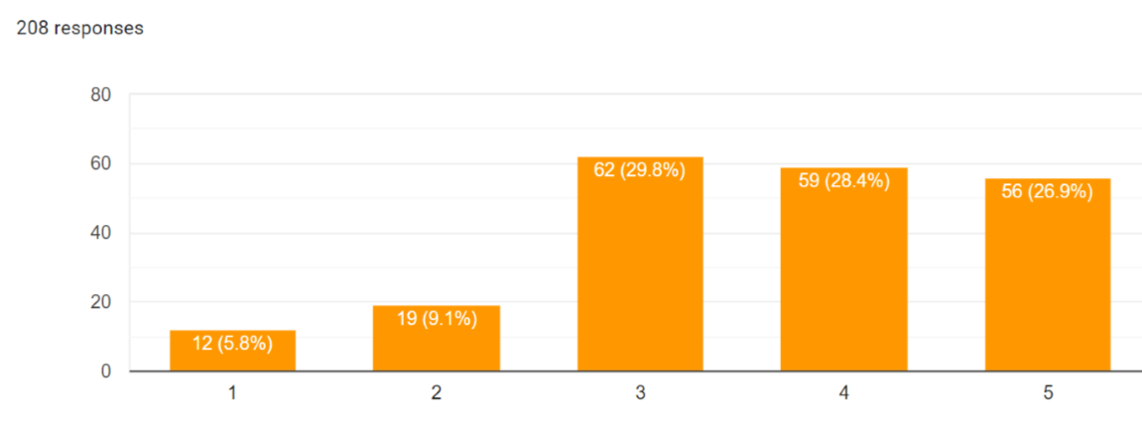
Fig.11
At the same time, according to my questionnaire, as can be seen in the image below, I found out that out of 208 Romanian respondents, only 22 (10.6%) want to carry out an economic activity in the UK, 49 respondents (23.6%) do not know, and most of them chose not to carry out an economic activity, 135 respondents voted no (64.9%), one person specified that he was already carrying out an economic activity, and another person opted for the "possible" answer. Thus, from the perspective of this field, the economic one, I can say that Romanian citizens feel affected commercially, being difficult for them to access the UK market, but also from the point of view of restricting accessibility in the UK and travel. Other Romanian citizens expressed their opinion and argued that they feel affected economically, because they are European citizens, and for tourists it is more difficult to travel, there is an economic crisis in the UK and it is a sceptical area.
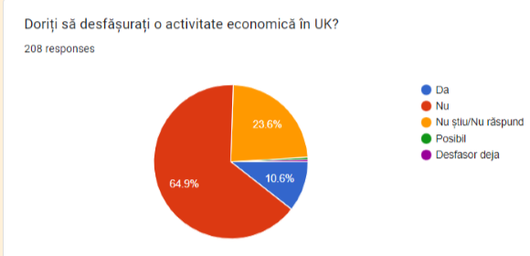
Fig.12

Social area
Another interesting thing is that 84.6% of the Romanian subjects have relatives/friends/acquaintances who work or study in the UK and 93.8% do not live there, only 6.3% live in the UK, some have been living for 2 years, others for 9 years. Of those who live there, 53.1% are not enrolled in the EU Settlement Scheme, 48% own pre-settled, 28% hold selttled, 24% are going to have this status.
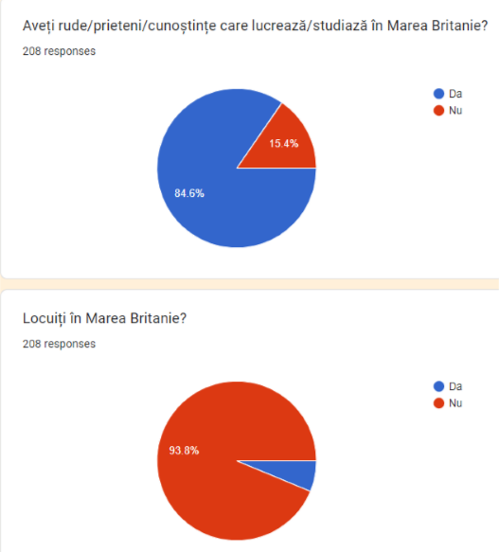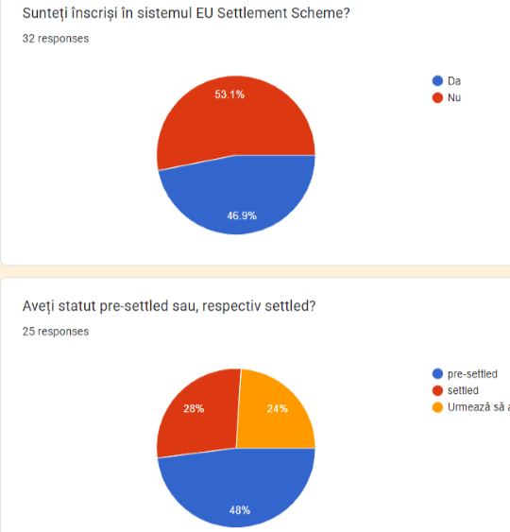
Fig.13 Fig.14

Also, from a social point of view, according to the image below, it can be noted that the Romanian subjects are of the opinion that there will be consequences regarding this phenomenon, voting from 1 to 5, as follows:
- 1 (to a very small extent) = 7.7%;
- 2- 11.1%;
- 3 – 30.3%;
- 4 – 26.9%;
- 5 (to a very large extent) – 24%.
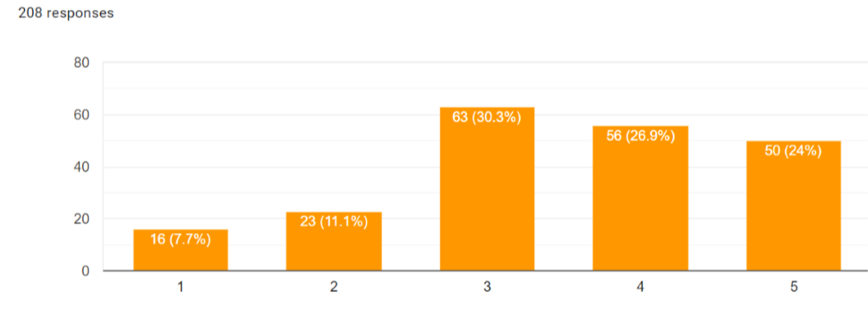
Fig.15

Romanian citizens were asked to what extent they are affected by this Brexit phenomenon, being forced to choose between 1 and 5, where 1 means to a very small extent and 5 means to a very large extent. Thus, out of 208 Romanian subjects, 55.8% (116 subjects) chose option 1, to a very small extent, 23.1% opted for position 2, 16.3% for position 3, and for the last two positions, 2.4%, meaning to a very large extent. Half of them do not consider themselves affected, or are affected to a very small extent.
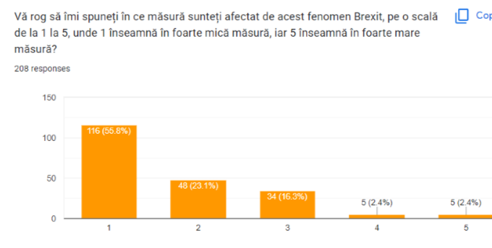
Fig.16
Going further, on a scale from 1 to 5, where 1 means to a very small extent, and 5 means to a very large extent, the Romanian subjects were asked to what extent they think this phenomenon affected their loved ones, and the figures show that 33.7% opted for position 1, 15.9% for position 2, 26% for position 3, 15.9% for position 4 and 8.7% for position number 5.
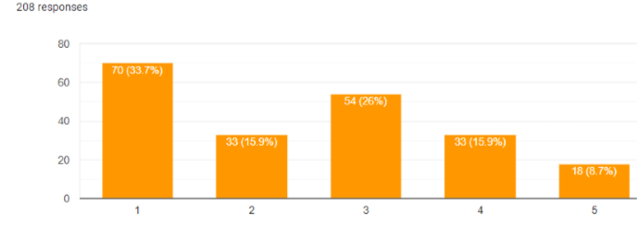
Fig.17
A first disadvantage is that of young Romanians who want to work, travel or study in the UK, feeling demoralized, because the British are constraining their citizens from the benefits offered by the union, destabilizing the union by creating a precedent by withdrawing them plus that the vast majority of immigrants were working for the proper functioning of the economy. Thus,when asked if they wanted to study in the United Kingdom, 76.4% of the Romanian subjects expressed their opinion with no, 11.5% - yes, and 12% - do not know. Asked if they wanted to work in the UK, 64.9% of romanian subjects chose no, 14.9% - yes, 20.2% - I don't know. Another Romanian student studying in the UK specified that he had to pay €36000 and other expenses, with prices rising more and more. Another student tells us that "I havecompleted my undergraduate studies in the UK in 2020 and am affected by the "student loan" payment and the lifting of the status of "pre settlement".
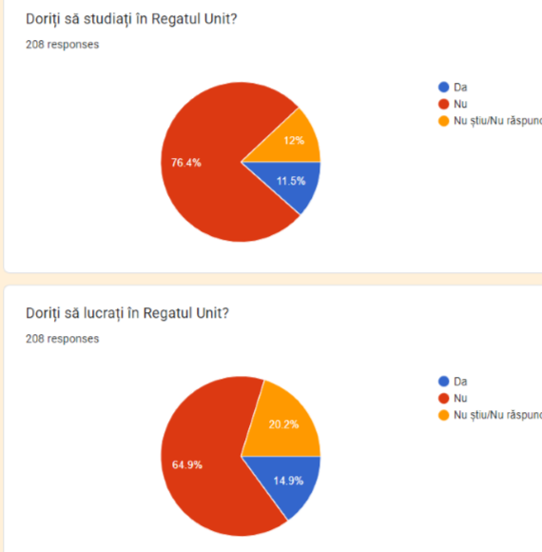
Fig.18

Tourism area
It can be noted that another disadvantage of this Brexit phenomenon is that of tourism and the low number of students, but also of employees, due to restrictions and limited access to stay and studies, but also to very high prices. It is also worth mentioning that European citizens are having to pay customs duties and a higher VAT on the products purchased from there, waiting enormously for their products to come, and it is a longer and more difficult process. Romanian citizens who want to work in the UK specify that obtaining a visa to be able to work there makes the whole process more difficult. Even those who are passionate about travel feel the effects of this phenomenon, saying that "yes, it affects me, due to the fact that it limits free movement and it is harder to travel for tourist purposes"; " It affects me in terms of travel. Now it is a much more complex process to visit the country. ". Returning to my study, from a tourism point of view, the subjects were asked if they had visited the UK, and the figures recorded are as follows: 40.9% of Romanians visited the country, 52.9% did not travel to the UK, but they wanted this, 3.8% did not visit or want to visit the United Kingdom, and the remaining 2.4% lived there, or are still living, or not sure if in the future they will want to visit the UK.
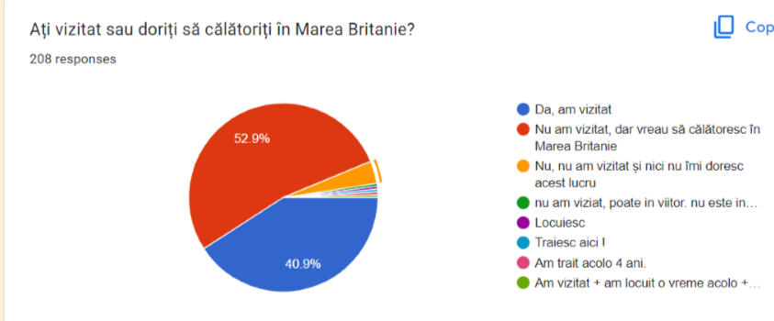
Fig.19

Voting and consequences
Going along the same lines, to the question "Towhat extent do you think this phenomenon has made people aware of the importance of involvement and participation in the vote, on a scale of 1 to 5, where 1 means to a very small extent, and 5 means to a very large extent? ", the following replies were recorded: 1 (to a very small extent) = 9.1%; 2 - 14.4%; 3 – 27.4%; 4 – 26.9%; 5 (to a very large extent) – 22.1%. Interestingly, more than half of the Romanian respondents, namely 65.4% - 136 of the Romanian subjects would have participated in the vote to a very large extent, if they had been in the place of the British citizens, according to the image on the right side.
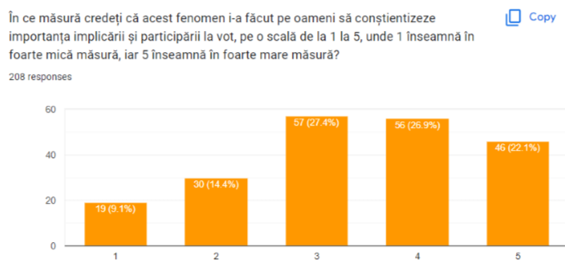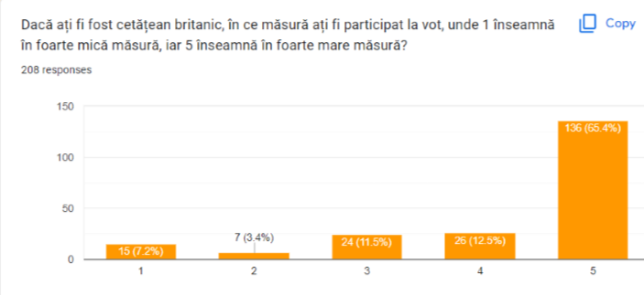
Fig.20 Fig.21
Those who consider themselves affected by this process, Brexit, have argued the following: " Directly, I do not feel the effects. Indirectly, I think I am affected in terms of what has happened at EU level, with the exit of a Member State and the change in the balance of forces in the EU Council"; " Directlynot and not at present, but if I want to operate in the UK market, it will be difficult for me to access." To some extent yes, because I hope it's not an obstacle in my way and dream of studying in the UK." Yes, every European citizen is affected by this process. For example, for tourists it is a skeptical field, they can no longer travel because there is an economic crisis there now, and many other disadvantages."
As can be seen from the chart below on the left, out of the total number of Romanian respondents included in the batch of the case study, 7.2% said that the European Union is affected to a very small extent, 13% chose position 2, 42.8% position 3, 24% position 4, and only 13% consider that the EU is affected to a very large extent. At the opposite pole, the Romanian subjects are of the opinion that the United Kingdom is affected to a very large extent, choosing the 4th – 29% position and the 5th position with 27.4%.
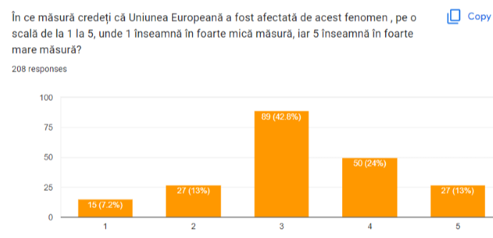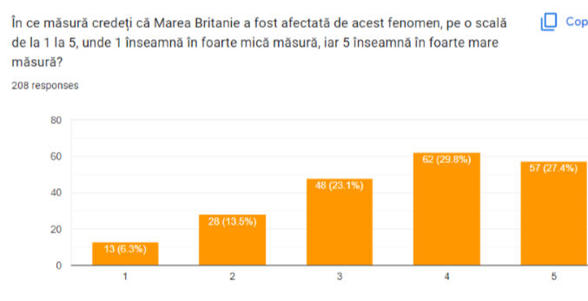
Fig.22 Fig.23

Future prospects
To the question: "Do you think that other European Member States will leave the EU? If so, what states do you think will do this?" , some of the subjects (136) said no, because "I think it's very hard now, after seeing how complex the process is.", "In the current circumstances, I don't think any country will leave the EU.", another 30 subjects said they do not know yet because it is too early to intuit this, another part (8 subjects) said that little / maybe, "Unlikely to happen in the next 8 years.", and another party replied with yes (36 subjects) "Yes, in order to be financially independent", and the states mentioned are: Hungary (it has been specified 17 times), Poland (5), France (5), Germany (3), Spain (2), Denmark (1), Romania (1), Bulgaria (1), Ireland (1). The opinions of the subjects are interesting, so one can notice a skepticism: "I think that in the coming years there will be states that will leave the EU and thus it will fall apart.", "It is very possible in an unpredictable context.", "Probably in the next years, after the end of the war in Ukraine. Taking into account all the price increases in the last period and the EU's desire or requirement to standardize prices, which I think is not possible since wages are not at the same level in all Member States. America's interests in selling us oil and natural gas at triple prices at least mercilessly taking advantage of this war."

The EU - a major global player
At a global level, the United Kingdom was an important financial player, but also an important economic power at the level of the European Union, in terms of the amount contributed to the European Union budget in 2020, per member state. Thus, according to the table below, it can be noted that Great Britain was ranked 3rd, with a percentage of 17.075% billion euros invested in the EU, after Germany with 28.064% and France with 23.689%.
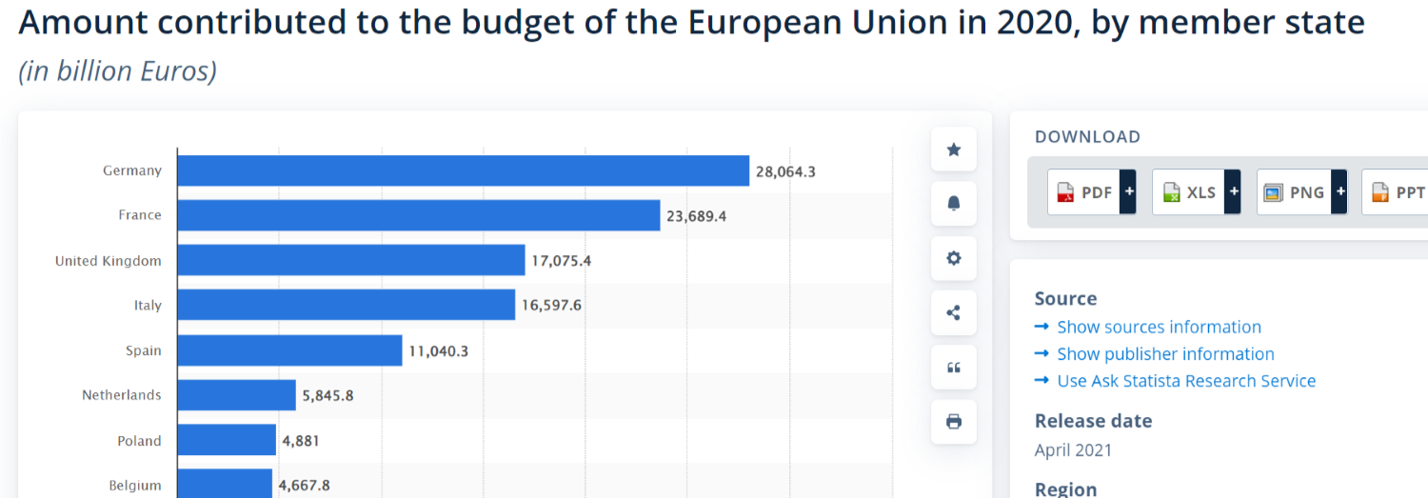Fig.24 - Imagine: Statista, Amount contributed to the budget of the European Union in 2020, by member state(in billion Euros) https://bit.ly/3ne09kx

However, according to the answers provided by the respondents included in the study group, to the question "Do you think the EU can be an important player globally and without the UK?", some of the subjects (136 out of 208) answered with yes, while 57 chose the answer option no, 15 chose the option they do not know. Their opinions are interesting: " Yes, he is still an important actor. Of course, it seems that the Union, similar to a federal state, seems to be weak, but the way it works and the fact that the EU is still beneficial to its members, will make the EU remain a relevant player.", "Yes, because the EU involves several countries, which can reach by themselves the economic, cultural and political competences pursued by the European plan." .

Conclusions
After Britain's exit from the EU, a process unexpected even by David Cameron's cabinet, the EU appears to be a stronger continent on the international order and the principles of democracy. Angela Merkel said the EU has to deal with the consequences of Brexit and look at the future of the EU. "Citizens will only accept the EU if it allows them to thrive." Change produces new stages, but can the stability that the EU had be replaced by instability, fragmentation after this process? After the confrontation with the pandemic health crisis of 2020-2022, the Russia-Ukraine conflict arises, which has shaken the EU and made European citizens and leaders realise that the EU can help and support, prosperity, integrity, solidarity. Following the conflict triggered by Russia towards Ukraine, the EU has inspired trust and stability at a global level, especially among European, but especially Ukrainian, citizens. Thus, the UK's exit from the EU has produced numerous bottlenecks in its relationship with EU states and even within its own territories (disagreements with Scotland, trade issues with Ireland, social discontent), and this phenomenon has placed the UK and the EU in a vulnerable international position.
I conclude by saying that this process has been and is difficult to accept for both British and European citizens, with numerous comments and analyses on this subject appearing over time. Even though not much time has passed since the UK left the EU, negative effects can already be seen in areas such as the economy, tourism, the labour market, international relations, security and others. It was just a populist political maneuver of decentralization. It was also voted mostly by people who were uninformed about the choice made and especially about the consequences of this election. Yes, surely the EU can be an important player globally and without Britain, but it has lost a strong economy, but also a pragmatic partner that has contributed immensely to the development of the EU. Thus, the EU must be more united, less bureaucratic, and more decisive with regard to rogue states (especially Hungary and Poland).
So, the fact is that there are many stages and issues left to clarify, Brexit being just a challenge that the EU has gone through, being a deeper and more complicated issue. Thus, I can say that Britain is a free country that can make its own decisions in its favour, but which is forced to bear its consequences.

References:
- Article published by Hugo Brady, at the Center for European Reforms, The Schengen Dilemma of great Britain, dated 10.02.2009, site accessed on 6.06.2022, https://www.cer.org.uk/insights/britains-schengen-dilemma
- European Central Bank, "Globalization and strategy review", website accessed on 25.06.2022 https://www.ecb.europa.eu/home/search/review/html/globalisation.ro.html
- Clara Marina O'Donnell and Richard G. Whitman, JOURNAL ARTICLE - European Policy under Gordon Brown: Perspectives on a Future Prime Minister, International Affairs, Published By: Oxford University Press, Vol. 83, No. 2, Europe at 50 (Mar., 2007)
- Foy, H, „Merkel says Brexit could be a breaking point for UE”, Financial Time, entered into 26.06.2022 https://www.ft.com/content/ad3d4cc9-5c8b-36cd-b6c5-efd57842909b
- The Official Journal of the European Union, the Treaty on European Union and the Treaty establishing the European Community (OJ C 306, published on 17.12.2007), entered into force on 1 December 2009 EUR-Lex - 12007L/TXT - EN - EUR-Lex (europa.eu) accessed on 22.6.2022
- Statista Official Page, Contributions to the European Union budget in 2020, article published by D.Clark, on 22.02.2022, website accessed on 23.06.2022 https://www.statista.com/statistics/316691/eu-budget-contributions-by-country/

Article published by Hugo Brady, at the Center for European Reforms, The Schengen Dilemma of great Britain, dated 10.02.2009, site accessed on 6.06.2022, https://www.cer.org.uk/insights/britains-schengen-dilemma
Clara Marina O'Donnell and Richard G. Whitman, JOURNAL ARTICLE - European Policy under Gordon Brown: Perspectives on a Future Prime Minister, International Affairs, Published By: Oxford University Press, Vol. 83, No. 2, Europe at 50 (Mar., 2007), pp. 253-272
The Official Journal of the European Union, the Treaty on European Union and the Treaty establishing the European Community (OJ C 306, published on 17.12.2007), entered into force on 1 December 2009, https://eur-lex.europa.eu/legal-content/RO/TXT/?uri=CELEX:12007L/TXT, accessed on 22.06.2022
The Official Journal of the European Union, the Treaty on European Union and the Treaty establishing the European Community (OJ C 306, published on 17.12.2007), entered into force on 1 December 2009, https://www.europarl.europa.eu/ftu/pdf/ro/FTU_1.1.5.pdf
European Central Bank, "Globalisation and strategy review", website accessed on 25.06.2022 https://www.ecb.europa.eu/home/search/review/html/globalisation.ro.html
Statista, Amount contributed to the European Union budget in 2020, by member state (in billion euro)
Official Statista Page, Contributions to the European Union budget in 2020, article published by D.Clark, on 22.02.2022, site accessed on 23.06.2022 https://www.statista.com/statistics/316691/eu-budget-contributionsby-country/
Foy, H, „Merkel says Brexit could be a breaking point for UE”, Financial Time, accesat pe 26.06.2022 https://www.ft.com/content/ad3d4cc9-5c8b-36cd-b6c5-efd57842909b

