Persuasive effects of nonverbal elements in interpersonal communication
Sebastian-Claudiu Nistor

Sebastian-Claudiu Nistor (born 1997, Bucharest) is a student at the PhD School of the National University of Political Studies and Public Administration, in the field of Communication Sciences. His areas of interest are online disinformation, political science and the influence of nonverbal elements in communication.
Contact information:
mailing address: 10 Petru Rareș Street, Voluntari, Ilfov, Romania, 077190
mobile phone: 0734.317.046
e-mail: sebastian.nistor.23@drd.snspa.ro

Abstract
Nonverbal elements play a fundamental role in interpersonal communication, giving expressiveness to social interactions. The main objective of this study is to provide a theoretical perspective on how nonverbal elements influence a conversation from the very first moments of an interaction. Although they often play an informative and constructive role in communication, there are situations in which such elements can play a persuasive role, for example when aiming to dominate a conversation, or when trying to determine people to act in a certain way. This article highlights both types of roles. In doing so, various communication situations, as discussed in the literature, are examined. Nonverbal elements analysed here are gestures, facial expressions and eye contact/gaze. Based on current literature in the field, I assumed that nonverbal elements may cause interlocutors to become vulnerable to persuasion when they are engaged in a dialogue or to adopt certain behaviors depending on the sender's intentions. For this purpose, I conducted a qualitative experiment involving 16 people, aged between 20 and 42. The findings of this study have shown that nonverbal elements could be used for persuasive purposes. In addition, the results highlight and provide new ways of empirical investigation of these persuasive effects of nonverbal elements, proposing innovative approaches in the field of nonverbal communication, and thus in the evolution/development of civil society.
Keywords: Nonverbal; Persuasion; Society; Interpersonal Relations
Introduction
Nonverbal elements play a fundamental role in interpersonal communication (Dash & Davis, 2022), whether referring to certain gestures that people use to adapt to various social situations, to facial expressions or to the functions performed by the role of gaze (Wang et al., 2022). While they can be used to enhance communication or facilitate the transmission of information, there are also situations where nonverbal elements can be used for persuasive purposes as well (Jackob et al., 2011).
Numerous studies have emerged on this topic, most of them examining the potential effects of using nonverbal elements on a large scale. However, it is not known what the effects might be in certain circumstances. There is little research examining their impact by geographical area, and in this context, it is not known whether these effects are universal or whether they differ across cultures.
This article investigate the potential effects of the use of nonverbal elements, the novelty being that it will analyse both their persuasive value and their positive influence on increasing the level of trust between interlocutors. The effects of using gestures, facial expressions, and eye contact will be discussed, testing the premises in Romanian society.
Concerning the first nonverbal element stated, an experiment shows that the absence of gestures in a conversation leads to a lack of expressiveness of speech. (Knapp et al., 2013). In certain situations, they can facilitate the transmission of information in interpersonal relationships and they are fundamental in interpersonal communication (Schneider et al., 2022). For instance, in a speech, gestures can be a way of emphasizing certain words to give credibility to the message, or to complete the language (Poggi & Vincze, 2009). The use of gestures could be useful, as it allows to deliver the essential information to audience/public. In this case, through certain types of gestures, the public can find out/understand what are the most important points of the discourse, and, at the same time, people can focus their attention on the essential elements of the speech. People use gestures when they want to steer the conversation in a certain direction or when they want to emotionally emphasize different parts of speech (Kapitanov et al., 2024). In this sense, gestures can help subjects to catch the interlocutor's attention, and to emphasize certain elements they consider important, when they are engaged in a dialogue. Therefore, their role in interpersonal communication is essential, as conversation involves an interaction based on a continuous transmission of information from sender to receiver (Dzamtoska-Zdravkovska & Haque, 2023).
However, if the broadcaster focuses only on information designed to influence people's opinions according to their own interests, the role of gestures becomes persuasive. Their possible persuasive value was highlighted by an experiment conducted by Maricchiolo et al. (2011). In the study, it was shown that during an interaction, words are not strong enough to support the conversation, but the use of gestures could be a way to uphold it, but also to dominate it. This is possible because most people tend to positively evaluate a speech in which the interlocutor has used certain gestures (Peters & Hoetjes, 2017). A pertinent example can be found in political discourses (Poggi & Vincze, 2009). Consequently, if the speech in question aims to influence people in the direction the speaker wants, gestures can become persuasive.
Although it can be claimed that gestures can play both a positive and a persuasive role in communication, their effects in certain circumstances are not well known. For instance, it is not known whether the use of gestures in interpersonal communication can increase the level of trust between interlocutors, how the use of gestures can influence interpersonal communication in a persuasive way, or what are the directly consequences for people.
Regarding the second nonverbal element discussed, i.e. facial expressions, they are essential in communication and in interpersonal relationships. This class of nonverbal elements can enhance the level of mutual confidence between individuals, being particularly important in human-to-human interactions (Azami et al., 2022). Conversation can be entertained in an adequate way, and interlocutors can exchange information, according to their own feelings, because there is a strong connection between facial expressions and people's emotions (Sajjad et al., 2023). Therefore, through facial expressions, people will be able to understand the sender's feelings. In this way, as with other nonverbal elements, the transmission of information from the sender(s) to the receiver(s) will be done in a proper way, and the interpersonal communication will be effective because the conversation will be expressive. Its expressiveness is a fundamental element for the development of interactions between individuals (Kimmel et al., 2023). Suppose certain political actors hold a discourse in public, and discuss certain civil society issues. If the speech is an expressive one, the confidence level of the interlocutors will increase, and they will emphasize its fundamental features. Therefore, the message of the political actors will be convincing, and if the issues discussed are of public interest, it will be correctly interpreted by the interlocutors. This situation highlights that such nonverbal elements can help the development of human relations/civil society, by correctly decoding a message and by improving the level of mutual trust between people involved in a conversation. In addition to conveying information that can be achieved, it is known that people can control the facial expressions they display at any given moment, or display other emotions, for persuasive purposes (Namba et al., 2022). The interlocutor's opinion can be influenced, and the conversation can be steered in the direction desired by the sender. In this regard, Yu et al. (2022) point out that in some situations, people's behaviour can be influenced by other people's facial expressions.
Persuasive action can occur when attempting to display certain emotions for a particular purpose. A relevant example is provided by Sülflow and Maurer (2019). The authors outline that facial expressions can, in certain situations, be powerful tools for creating a favorable impression of a particular person. The researchers also indicate that they can be used for the purpose of grabbing attention and emphasizing certain ideas. It follows that interlocutor can use facial expressions to underline only the information he wants to convey further.
In this case, the roles/effects of facial expressions in interpersonal communication can be outlined, but there are only few studies that show how this type of nonverbal element can increase confidence between speakers, or how it can affects the audience in a persuasive way.
The last nonverbal element examined in this paper is the eye contact/gaze. This is critical for effective communication, being a ubiquitous element in initiating a conversation (Luft et al., 2022). A relevant study has shown that during a job interview, eye contact is particularly important, sometimes being decisive for passing it successfully (Artiran et al., 2024). Thus, the idea has been put forward that maintaining eye contact with the employer increases the chances of being hired. The role of gaze in interpersonal relationships is significant because, as with facial expressions, it can lead interlocutors to trust each other more (Alforque et al., 2023). When their level of trust is high, communication between individuals is carried out in an efficient way, which can lead to the strengthening of interpersonal relationships and, also, to the correct transmission of information from sender(s) to receiver(s). The correct transmission and decoding of the message can be a fundamental component regarding social development, since civil society is shaped on a good interpretation of the content of communication (Burgoon et al., 2021).
However, in some situations, eye contact may be intended to dominate the interaction, or it may be used for persuasive purposes (Dzardanova et al., 2022). Fromme and Beam (1974) conducted an experiment, involving 32 people. Participants were divided into several groups, each of them having the task of approaching the other individuals until they felt comfortable. During this time, they were asked to maintain eye contact for as long as possible. The experiment results revealed that, in some cases, maintaining eye contact with interlocutors was increasingly difficult. The authors concluded that people who found it difficult to do so felt dominated by the rest of the group. If the individual feels dominated, there is a chance of becoming vulnerable to persuasion and acting differently, contrary to previous intentions.
Nevertheless, these persuasive effects are not generally valid, as perception may differ from culture to culture, and from individual to individual.
Given the issues involved, nonverbal elements can play different roles, depending on the context but also on the interlocutor's intention. This article aims to assess both how nonverbal elements can influence human behavior, including their possible persuasive value, and how they are interpreted/understood by the interlocutors in Romanian society.

Methods
Design
The research involved an experiment, as a qualitative research method. The qualitative experiment is exploratory and can help to identify certain similarities/differences in the behavioural patterns of participants (Steils, 2021). The aim of the present study is to be a preliminary research that will give the premises for a full quantitative experiment with a big sample. In this case, it's just checking if there are any premises worth investigating.
The present study was carried out on (N=16) people who were part of the experiment. The respondents were aged between 20 and 42 years, and were divided into two groups (experimental group and control group). People in the experimental group were exposed to a nonverbal persuasive action, and people in the control group were not exposed to any stimulus. The types of nonverbal elements used in this study are tapping on the shoulder, facial expressions displaying positive emotions, and maintaining eye contact. They were chosen considering their potential to have a persuasive impact on the audience, and were administered by the experimenter. Specifically, I examined the differences between the behaviors of people who had been subjected to a nonverbal manipulative act (tapping on the shoulder, facial expressions, and holding eye contact) and the behavior of people who had not been subjected to it (the control group). Handling consisted of trying to influence subjects in the experimental group to act according to the experimenter's intentions after being subjected to persuasive nonverbal actions.
Subjects
All participants were randomly selected in a face-to-face interaction. Of these, eight people were part of the experimental group and eight were part of the control group.
Research questions
This research is based on the following research questions:
RQ1. How can nonverbal elements influence interpersonal communication in a persuasive way?
RQ2. Is the level of trust on the interlocutor influenced by nonverbal elements?
Experimental steps
The experiment was conducted as follows:
All participants, regardless of which group they belonged to (control group or experimental group) were asked to express their opinion on various social situations. Participants were asked to state their opinion about the ideal political candidate, what the government's priorities should be, or what are the main ways to combat the current social problems. They were allowed to speak freely, with the aim of creating a pleasant environment, and also to encourage them to take part further in the experiment. After this stage, all participants were asked to complete a questionnaire consisting of eight questions (Table 1) of which six were open questions and two were closed questions. The questions assessed both respondents' perceptions of the experience and their perceptions of other topics of public interest, again touching on various political and socially sensitive issues. Participants were intentionally informed that their answers would not remain anonymous, and would be passed on to specific press agencies. This fact was not true, but they were told so, because the purpose of the experiment was to see whether subjects would agree to complete the questionnaire knowing these details. Consequently, in addition to being verbally informed that responses would not be confidential, participants were, also, asked to fill in the questionnaire their full name, age, and gender. In an attempt to encourage them to answer the questions in the questionnaire, respondents who belonged to the experimental group were exposed to subtle persuasive nonverbal actions (tapping on the shoulder, using facial expressions that displayed positive emotions, and maintaining eye contact with them). On the other hand, respondents who belonged to the control group were not subjected to these nonverbal actions, and were asked to fill in their answers without using gestures, facial expressions, and without maintaining eye contact with them. Therefore, if subjects from the experimental group agreed to answer the questions after having been subjected to the nonverbal actions, it is considered that these nonverbal elements led them to act in this way, i.e. in compliance with the sender/experimenter's intentions. If control group respondents declined to answer the questionnaire questions, it was believed that the lack of use of the nonverbal elements mentioned above led to their refusal to complete it.
When subjects were asked to complete the questionnaire, their behavioural reactions were noted, regardless of which group they belonged to. This has been done in order to observe the possible behavioural reactions of both those who were exposed to the stimulus (experimental group), and those who were not subjected to nonverbal persuasion (control group). Also, this has been done for a better interpretation of the experiment results, and for identifying the behavioural reactions associated with the use of nonverbal elements.
At the end, all participants, regardless of their group, were informed that they had taken part in an experiment and the results of this research will be used for educational purposes only.
The experiment aimed to investigate the response differences between the experimental and control groups. It was assumed that the use of gestures, facial expressions and maintaining eye contact would cause the experimenters to have an increased level of confidence in experimenter, and to agree to complete the questionnaire.
The results of this study aimed to answer the research questions, when there were significant differences in response between the two groups. In short, the main idea behind this experiment is how nonverbal elements can persuade people, how they can cause people to act in a different way, and, at the same time, how they can influence the level of trust in interlocutor.
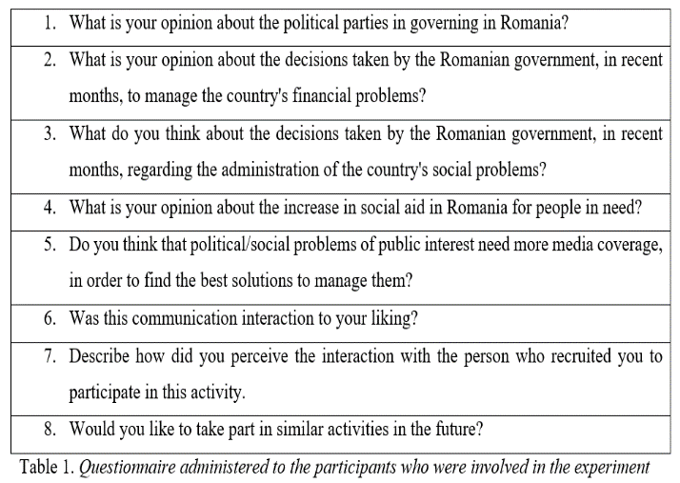

Responses
Experimental group
The first subject (20 years old, male) agreed to complete the questionnaire, even though he was informed that the answers would not be kept confidential. He answered all the questions, stating that he would like to have such interactions in the future. Behavioural responses identified: high level of trust in the experimenter, appreciation, safety. The second respondent (25 years old, female) agreed to answer the questions. Again, the participant answered all questions, specifying that she had a pleasant interaction with the experimenter. Behavioural reactions identified: high level of trust in the experimenter, relaxation, good mood. The third person (41 years old, female) answered all questions in the questionnaire. She also specified that she would like to participate in such activities again, stating that she did not feel nervous, because the interaction with the experimenter was pleasant. Behavioural reactions identified: high level of trust in the experimenter, relaxed behaviour, positive attitude. The next respondent (38 years old, male) did not agree to answer the questions in the questionnaire, even though persuasive nonverbal elements (tapping on the shoulder, facial expressions, and maintaining eye contact) were used. In this situation, the interaction with this individual did not lead in the expected direction. Behavioral reactions identified: lack of trust in the experimenter, lack of interest, suspiciousness. The following participant (34 years old, male) answered all the questions in the questionnaire. He provided positive communication feedback towards the experimenter. Behavioural reactions identified: high level of trust in experimenter, increased self-esteem, relaxation. The sixth participant (40 years old, female) agreed to answer all the questions in the questionnaire, specifying that the experience she had was enjoyable/interactive, and it was a pleasure to interact with the experimenter. She felt comfortable, and did not indicate any negative emotions. Behavioural reactions identified: engagement, trust in experimenter, self-confidence. The next subject (42 years old, male) agreed to complete the questionnaire and answered all the questions which were asked. He underlined he was not nervous when he found out that the answers would not remain confidential. Behavioural reactions identified: increased level of trust in the experimenter, relaxed behaviour. The last participant (25 years old, female) agreed to complete the whole questionnaire, explaining that it is normal to answer certain questions when being part of an experiment. The subject also did not seem bothered by the idea that the answers would not be anonymous. Behavioural reactions identified: positive attitude towards the experiment, positive attitude towards the experimenter, high self-esteem.
Control group
The first control group subject (24 years old, female) refused to complete the administered questionnaire. It was, therefore, noticeable that she refused to become further involved in the experiment. This was identified when the subject was informed that her answers would not remain anonymous. From the behavioural elements that were identified in relation to the communication attitude she had when she was asked to answer the questions in the questionnaire, one can highlight her lack of trust in the experimenter. Other behavioural reactions identified: insecurity/uncertainty, inferiority, disobedience. The second participant (41 years old, male) refused to complete the questionnaire. When it was explained to him that it would be helpful if he completed the questionnaire, but his answers would not remain anonymous, he indicated that he did not want to be any longer part of the experiment. So the conversation proceeded in the direction the sender wanted. Behavioural reactions identified: lack of communication, lack of motivation, anxiety. The following participant (23 years old, female) agreed to complete the questionnaire, even though it was explained that the answers would not remain anonymous. In this case, the conversation was not directed in the direction desired by the sender. She answered all the questions. Behavioural reactions identified: high level of trust in the experimenter, increased self-confidence, determination. The fourth subject (31 years old, male) did not agree to complete the questionnaire, when he was informed that the answers would not remain confidential. This participant's behaviour highlighted his lack of interest in completing the answers. This behaviour was underlined by the way he reacted when he subsequently heard what the experiment entailed. Behavioural reactions identified: keeping a long distance from the experimenter, ignorance, uncertainty. The following subject (38 years old, female) agreed to answer the questions in the questionnaire. In this situation, the interaction between experimenter and participant was not conducted in the direction expected by the experimenter. She answered 6/8 questions. Identified behavioural reactions: high level of trust in the experimenter, increased self-confidence. The following participant (26 years old, female) did not agree to complete the questionnaire, after finding out that responses would not remain confidential. In this case, the communication feedback highlighted her tendency to not empathise with the experimenter, although she showed engagement with this activity during the experiment. Behavioural reactions identified: lack of empathy, lack of involvement, concern. The seventh respondent (34 years old, male) did not agree to complete the questionnaire, after learning that the responses were not anonymous. The participant's attitude conveyed a lack of trust in the experimenter. Identified behavioural reactions: lack of confidence, low self-esteem, anxiety. The last subject (40 years old, male) refused to complete the questionnaire when he was advised that his answers would not remain confidential. Behavioural reactions identified: keeping a large distance from the experimenter, lack of trust, confusion.

Findings
The results of the experiment revealed that seven of the eight subjects who were part of the experimental group agreed to answer the questions in the questionnaire after nonverbal elements (tapping on the shoulder, facial expressions and maintaining eye contact) were used on them as manipulation techniques (Table 2).
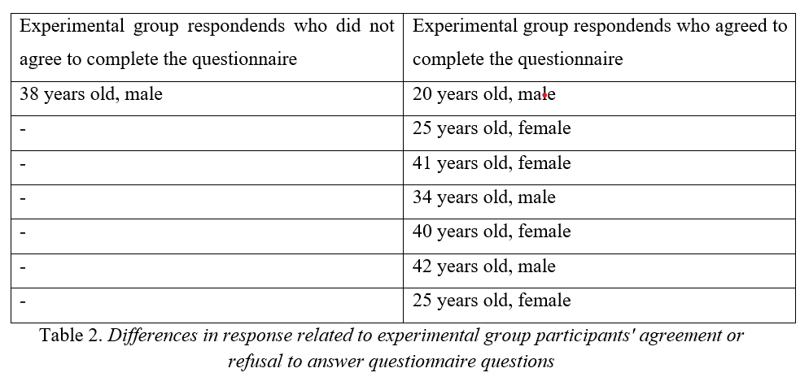
On the other hand, results show that of the eight participants who were part of the control group, six did not agree to complete the questionnaire, when they learned that their answers would not remain anonymous and would be passed on to certain news agencies (Table 3).
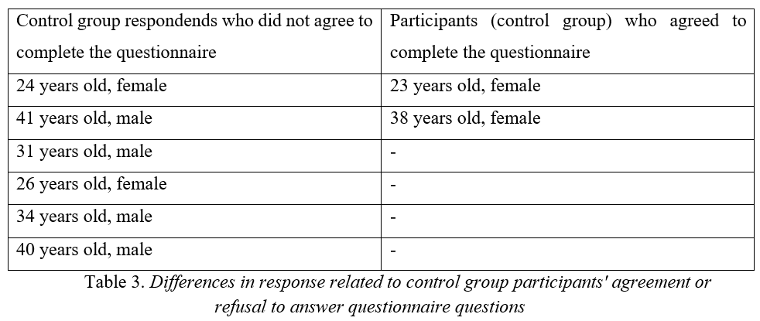
Several fundamental differences can be observed between the two groups analysed. While positive emotions were specific to the experimental group, negative emotions predominated for the control group. In the case of the control group, the lack of nonverbal elements was associated with the following: lack of confidence, anxiety and insecurity, inferiority, keeping a large distance from interlocutors (both due to lack of self-confidence and due to lack of confidence in interlocutors), ignorance, confusion, indecision, lack of motivation, disobedience, lack of empathy, and lack of involvement. According to the responses, the lack of nonverbal components was associated with these negative characteristics, as verbal language does not have the capacity to fully sustain a conversation. Thus, it was observed that the absence of nonverbal elements of persuasion was primarily associated with a lack of trust in the experimenter, because this creates the impression that sender does not provide the desired communicative feedback. In the case of the participants, the lack of trust in the experimenter, created by the lack of nonverbal elements in the interaction, led to insecurity, from which confusion, indecision, and ignorance were subsequently engendered. These factors led to poor motivation and disengagement in the experiment. All this ultimately led to disobedience; a circumstance proven by the fact that majority of people who were not subjected to nonverbal elements as manipulative techniques did not agree to complete the questionnaire. Thus, most of the respondents who were not subjected to the elements of persuasive nonverbal action did not act according to the experimenter's intentions.
On the other hand, the use of persuasive nonverbal elements in the interaction was associated with positive emotions, with an elevated level of trust in the experimenter, with the involvement of participants in the experiment, and with a positive attitude towards the experiment. At the same time, however, it can be appreciated that their use caused most of the respondents involved in the experiment to act according to the sender`s intentions, causing them to answer the questions in the questionnaire after being subjected to nonverbal persuasion.
This suggests that nonverbal elements can influence people to make certain decisions or change their behaviour, being, sometimes, responsible for misleading interlocutors. At the same time, from the results of the present study, it can be seen there may be a connection between nonverbal elements and the action of dominating someone (Dzardanova et al., 2022).
Discussions and conclusions
The experiment highlights two fundamental matters regarding the use of nonverbal elements. The first is that gestures, facial expressions, and eye contact/gaze could be used as persuasive methods, because seven from eight participants exposed to nonverbal persuasion have acted in the broadcaster's desired direction; and the second is that, if used with positive intentions, they can contribute to the development of interpersonal relations, to the growth of trust between individuals, and also to the development of civil society (Azami et al., 2022).

RQ1. How can nonverbal elements influence interpersonal communication in a persuasive way?
I concluded that nonverbal elements can have a persuasive impact on the interlocutors, by making someone act differently, according to the sender's intentions. The research results revealed that, in certain situations, human behavior can change in the direction desired by the interlocutors.

RQ2. Is the level of trust on the interlocutor influenced by nonverbal elements?
Following the experiment, I concluded that people in the experimental group gave positive feedback to the sender, proving that the level of trust on the interlocutor could be influenced by nonverbal elements.
Although this is only an exploratory study, it seems that in Romania nonverbal elements can be used, in certain circumstances, as persuasive techniques, being, at the same time, related to enhancing the level of confidence in the interlocutor.

Limits
The limitations of this article are the small number of people who took part in the study, and also the qualitative interpretation of the results of this experiment. Therefore, this study cannot be representative for Romanian population, as people's responses may differ from individual to individual.

Literature
[1] Alforque Kayla, Mary Grace Balagapo, Jastine Deguito, Joseph P. Nacionales, and Norberto Claridad (2023): Eye’ll persuade you: exploring the use of eye contact among Filipino college student in persuasion. Journal of Language, Literature, Social and Cultural Studies, 1(2): 71-81.
[2] Artiran Saygin, Poorva S. Bedmutha, and Pamela Cosman (2024): Analysis of Gaze, Head Orientation and Joint Attention in Autism with Triadic VR Interviews. IEEE Transactions on Neural Systems and Rehabilitation Engineering, 32: 759-769.
[3] Azami Ritsuko, Mariko Kikutani, and Hideya Kitamura (2022): Perception of Hidden Confidence in Neutral Expressions: Interactions of Facial Attractiveness, Self-Esteem, and Names to Be Addressed by. Languages, 7(2): 1-14.
[4] Burgoon Judee K., Valerie Manusov, and Laura K. Guerrero (2021): Nonverbal communication. New York: Routledge.
[5] Dash, B., and Keith Davis (2022): Significance of nonverbal communication and paralinguistic featurs in communication: A critical analysis. International Journal for Innovative Research in Multidisciplinary Field, 8(4): 172-179.
[6] Dzamtoska-Zdravkovska Suzana, and Sabir Haque (2023): The theoretical basis of internal communication as an active process of information exchange. Technium Soc. Sci. J, 43: 252-262.
[7] Dzardanova Elena, Vlasios Kasapakis, Damianos Gavalas, and Stella Sylaiou (2022): Virtual reality as a communication medium: a comparative study of forced compliance in virtual reality versus physical world. Virtual Reality, 26(2): 737-757.
[8] Fromme Donald Karl, and Donna Clegg Beam (1974): Dominance and sex differences in nonverbal responses to differential eye contact. Journal of Research in Personality, 8(1): 76-87.
[9] Jackob Nikolaus, Thomas Roessing, and Thomas Petersen (2011): The effects of verbal and nonverbal elements in persuasive communication: Findings from two multi-method experiments, 245-271.
[10] Kapitanov Alexander, Karina Kvanchiani, Alexander Nagaev, Roman Kraynov, and Andrei Makhliarchuk (2024): HaGRID--HAnd Gesture Recognition Image Dataset. Proceedings of the IEEE/CVF Winter Conference on Applications of Computer Vision, 4572-4581.
[11] Kimmel Simon, Frederike Jung, Andrii Matviienko, Wilko Heuten, and Susanne Boll (2023): Let’s Face It: Influence of Facial Expressions on Social Presence in Collaborative Virtual Reality. Proceedings of the 2023 CHI Conference on Human Factors in Computing Systems, 1-16.
[12] Knapp Mark L., Judith A. Hall, and Terrence G. Horgan (2013): Nonverbal communication in human interaction. US: Cengage Learning.
[13] Luft Caroline Di Bernardi, Ioanna Zioga, Anastasios Giannopoulos, Gabriele Di Bona, Nicola Binetti, Andrea Civilini, Vito Latora, and Isabelle Mareschal (2022): Social synchronization of brain activity increases during eye-contact Communications biology, 5(1): 1-15.
[14] Maricchiolo Fridanna, Stefano Livi, Marino Bonaiuto, and Augusto Gnisci (2011): Hand gestures and perceived influence in small group interaction. The Spanish journal of psychology, 14(2): 755-764.
[15] Namba Shushi, Koyo Nakamura, and Katsumi Watanabe (2022): The spatio-temporal features of perceived-as-genuine and deliberate expressions. PloS one, 17(7): 1-18.
[16] Peters Judith, and M. W. Hoetjes (2017): The effect of gesture on persuasive speech. 659-663.
[17] Poggi Isabella, and Laura Vincze (2009): Gesture, gaze and persuasive strategies in political discourse. Multimodal corpora: From models of natural interaction to systems and applications, 73-92.
[18] Sajjad Muhammad, Fath U. Min Ullah, Mohib Ullah, Georgia Christodoulou, Faouzi Alaya Cheikh, Mohammad Hijji, Khan Muhammad, and Joel JPC Rodrigues (2023): A comprehensive survey on deep facial expression recognition: challenges, applications, and future guidelines. Alexandria Engineering Journal, 68: 817-840.
[19] Schneider Sascha, Felix Krieglstein, Maik Beege, and Günter Daniel Rey (2022): The impact of video lecturers’ nonverbal communication on learning–An experiment on gestures and facial expressions of pedagogical agents. Computers & Education, 176: 1-22.
[20] Steils Nadia (2021): Qualitative experiments for social sciences. New Trends in Qualitative Research, 6: 24-31.
[21] Sülflow Michael, and Marcus Maurer (2019): The power of smiling. How politicians’ displays of happiness affect viewers’ gaze behavior and political judgments. Visual political communication, 207-224.
[22] Wang Xinyue, Kelong Lu, Yingyao He, Zhenni Gao, and Ning Hao (2022): Close spatial distance and direct gaze bring better communication outcomes and more intertwined neural networks. NeuroImage, 261: 1-12.
[23] Yu Xin, Bo Xu, and Entao Zhang (2022): Others’ Facial Expressions Influence Individuals Making Choices and Processing Feedback: The Event-Related Potential and Behavioral Evidence. International Journal of Environmental Research and Public Health, 20(1): 1-12.

