Communication between publishers and the public: the magnetic effect of social media

In the contemporary dynamic and turbulent economic environment being *present* and *up to the minute* becomes a necessity for almost any business. Social media is a communication infrastructure that allows and concomitantly sets the rules for information and message dissemination. Just as most organizations nowadays, publishing houses need to establish a strong online presence through posts on social media platforms. As they are both economic and cultural agents, the messages shared by publishers on social networks imply a higher degree of social responsibility and their content is particularly important. The present paper aims to explore how Romanian publishing houses are communicating with their current and potential customers on social platforms. The posts on various social media such as Facebook, Instagram, TikTok, Twitter, etc. from the last two months of 2022 and the first two months of 2023 are investigated through the content analysis research technique. As the book industry is strongly linked to the concept of knowledge, the analysis is performed from the perspective of the Theory of Knowledge Fields. The findings of this study could prove useful to various actors involved in the book industry and other cultural organizations, as it provides insights into cultural promotion via social platforms practices. The subject is topical since book consumption is an essential part of a healthy cultural and social life of a country.

Keywords: book industry, publishing houses, social media, content analysis, Theory of Knowledge Fields

Ana-Maria Osadci-Baciu is currently a first-year Ph.D. student in the field of Management, at SNSPA's Multidisciplinary Doctoral School. She previously earned a Master's in International Business Management from the Bucharest University of Economic Studies, Faculty of International Business and Economics.

Alexandra Zbuchea is a professor of marketing communications at the Faculty of Management, SNSPA. She has a Ph.D. in Cultural Marketing and coordinates Ph.D. students in the field of Management. She is the Vice-dean of the Faculty of Management and the Coordinator of the Center for the Research of Responsible Organizations. She is the chief editor of the interdisciplinary academic journal *Culture. Society. Economy. Politics*, a member of various editorial boards, and a reviewer for prestigious publications.

*Introduction*

Effective communication is crucial in today's unpredictable and information-saturated business climate. For firms operating in knowledge-intensive cultural domains, such as publishing houses, conveying information to customers is a pivotal aspect of their business strategy. Since the publishing industry is still in its early stages in Romania and the market is narrow, publishing companies do not yet have highly sophisticated marketing strategies (Hrib 2018). However, in recent years, they have adopted a more modern approach and worked on developing more advanced communication strategies (Zbuchea and Hrib 2019). If this practice is further utilized and refined, it has the potential to raise awareness of books and make reading more appealing to the younger generation. This would be of significant social importance, especially in Romania, where the percentage of the population that reads regularly is relatively low (Hâncean and Oană 2018).

The information we encounter is stored in our brain as knowledge, consciously or unconsciously. How we interpret this knowledge is a matter of perception and is crucial in communication. However, perception is deeply influenced by individuals' emotions and beliefs (Kahneman 2013), particularly those fundamental to their worldview. Therefore, the messages disseminated by publishers on social media platforms are examined through the lens of the Theory of Knowledge Fields, which is based on the metaphor of "knowledge as energy" developed by C. Brătianu (2015). Similar to how energy can exist in different forms according to the laws of thermodynamics, knowledge can manifest itself in multiple ways. The Knowledge Fields model pertains to the three primary modalities through which humans acquire, store, and transform information into knowledge, namely rational, emotional, and spiritual (Brătianu and Bejinaru 2019). Fostering synergies between these distinct knowledge domains is essential for information understanding and dissemination.

The study is divided into several sections, in addition to the introduction. The literature review explores a broader range of research, including studies on the impact of social media on the publishing industry globally and in Romania, as well as models related to knowledge, such as knowledge conversion (Nonaka and Takeuchi 1995) and the theory of knowledge fields (Brătianu 2015, Brătianu and Bejinaru 2019). The methodology section explains the rationale behind the research, the context in which it was conducted, as well as the structure and actions taken for the study's purposes. It also identifies the limitations of the research and areas for future investigation. The findings and discussion section presents the results of the analysis, along with their interpretation and commentary. The conclusions section summarizes the key findings and highlights their implications. Finally, the section offers recommendations for improving social media activities for publishing houses.

*Literature review*

The book industry plays an important social role worldwide and is definitory for a country's cultural life. However, in recent decades, it has faced increased competition from other industries such as the film industry, television, digital media, and even the video game industry (Clark and Phillips 2019). These industries are more adapted to the increasingly dynamic world of today, where people have shorter attention spans and prefer efficiency, image-based information, and ease of understanding (Mosca et al. 2019). In addition to this, the industry has been deeply impacted by recent economic crises, as well as the COVID-19 pandemic, which has disrupted the way businesses operate across industries on a global level (Hrib 2020). In this context, as history has constantly reminded us that such "black swans" are possible and can escalate even more than in previous times due to increased global interconnections nowadays (Taleb 2012), the book industry, in general, and the publishing industry, in particular, need to adapt to these new realities to survive and thrive.

The increased importance of social networks in the business world is a part of this changing landscape (Almazrouei et al. 2020). Social media presence is essential for book marketing, which requires a comprehensive approach to establish a strong brand that differentiates from competitors. Platforms such as Facebook, Instagram, and Twitter can be highly effective tools for reaching a targeted audience, connecting with them, and building a loyal fan base. Choosing the right platform in accordance with the potential readers’ segment is also of increased significance. These platforms allow for advertising campaigns, as well as partnerships with industry professionals, authors, and public figures, and broadcasting of these collaborations (Baverstock and Bowen 2019). Online social media offers a variety of effective marketing techniques, such as sharing author and/or book information, running contests and giveaways, connecting with book influencers and bloggers, using paid advertising, and creating book clubs, among others. Additionally, utilizing analytics software can provide insights into readers' preferences and audience management (Nolan and Dane 2018).

Consistent social media posting can significantly impact book sales, but a strategic approach is necessary for a strong online presence. Specific tactics, such as book reviews, author interviews, and book excerpts, can generate deep audience engagement. (Luarn et al. 2015). There are some emerging trends in terms of the type of content that is being used on social media, for instance, increased use of video content (such as reels), collaborations with book influencers, user-generated content, and the use of multiple platforms. For example, many publishers are now leveraging TikTok as a way to engage with younger audiences (Tukia 2022). These strategies can help publishers to better reach and connect with potential readers, ultimately driving book sales.

The growing dependence on new technologies, including social networks, can pose significant challenges for small and medium enterprises. These companies may have limited resources and organizational knowledge, cash flow issues as well as insufficient tools to analyze data (Squires and Markou 2021). Therefore, SMEs need to adopt a strategic approach to social media and allocate resources appropriately to ensure that their efforts yield positive results. This is particularly relevant for the Romanian market, which is characterized by a significant number of SMEs. Global trends have also made an impact in Romania, with an increasing number of publishers adapting their activities to digital media in recent years (Balan 2015). Most of the local larger and medium-sized publishing houses have social media pages on Facebook and Instagram, which helps them understand their audience's feedback and needs. Usually, they coordinate with their recognized authors to build long-term relationships, showcasing the author's human side, organizing events, and fostering customer loyalty (Hrib 2018).

The use of social media can indeed be a winning strategy, but long-term success requires more than knowledge and actions, it is about creating and effectively communicating new knowledge. Innovation is key in developing effective approaches, from product design to establishing meaningful relationships with consumers. It involves envisioning new possibilities (Nonaka and Zhu 2012). This is entirely applicable to promotional activities and branding initiatives in the publishing industry. To make a difference, they must convey significant information to the general public, targeting both their rational and emotional sides, while constantly keeping in mind the broader cultural values and more sophisticated aspects that influence a person's reasoning (O'Bryan 2019).

Nonaka and Takeuchi (1995) posited that new knowledge within an organization is created through a process of knowledge transformation or conversion. This process involves interactions and synergies between two main types of knowledge: explicit (rational, easily shared) and tacit (emotional, experiential, hard to express). Four modes of knowledge conversion have been identified: socialization (in which tacit knowledge is created and shared through common experiences and social interaction), externalization (in which tacit knowledge is articulated and translated into explicit knowledge, through explanations and metaphors), combination (in which explicit knowledge is widely shared through documents, databases, meetings, and briefings), and internalization (in which explicit knowledge is absorbed into tacit knowledge through personal experience). Brătianu and Bejinaru (2019) build upon this background by utilizing the principles of thermodynamics as a metaphor for knowledge, and they present three main forms that knowledge may take: rational, emotional, and spiritual. These forms consist of varying proportions of tacit and explicit knowledge, with rational knowledge being predominantly explicit, while emotional and spiritual knowledge are predominantly tacit.

However, the "Theory of Knowledge Fields" framework provides a more nuanced understanding of these concepts. Rational knowledge is based on reason and logic, with information presented clearly and cohesively, and is associated with an analytical approach. In contrast, emotional knowledge is based on impressions, intuitions, and feelings. Kahneman (2013) describes two systems for processing information - "System 1" processes emotional information and creates a rapid perception of our environment, while "System 2" processes rational information through analysis of complex situations. Both systems interact and shape our knowledge, both consciously and unconsciously. In addition, understanding spiritual knowledge is crucial when discussing cultural aspects that are grounded in beliefs, values, and traditions (Brătianu 2015).

The three types of knowledge mentioned can be applied to the relationship between companies and their customers, particularly in the context of communication (Bolisani and Brătianu 2018). Rational knowledge pertains to companies providing their actual and potential customers with accurate information, such as product features and prices, presented clearly and understandably, allowing customers to make informed decisions. Similarly, emotional knowledge can assist in communication by resonating with people's emotions and feelings, thereby fostering the development of lasting relationships. This aspect can also have an impact on buying decisions, as they are often impulsive and based on emotional triggers. Spiritual knowledge is also very important, especially when it comes to cultural sectors such as the book publishing industry. Aligning with customers' values and beliefs, as well as educating them regarding important social issues, can be essential for businesses in this branch. Companies' social responsibility and ethical behavior now play a significant role in building trust and solidarity among the public, retaining existing customers, and attracting new ones who share similar values (Rendtorff 2019).

Understanding the three types of knowledge (rational, emotional, and spiritual) and their potential applications can be extremely helpful for companies in achieving more effective communication with their customers. With online communication prevailing, understanding how knowledge is transmitted through social media is crucial. Social media, when used strategically, empowers businesses to connect with customers. However, given the constantly evolving nature of business dynamics, it is important to note that social media is constantly changing too. While understanding the technical aspects is important, the message conveyed remains the essential element in communication (Majid et al. 2019). As a result, comprehending how to communicate messages effectively is necessary.

*Methodology*

This study employed the content analysis research technique to examine social media posts made by the top three publishing houses in terms of financial performance according to Forbes.ro (2022): Litera, Art Klett, and Polirom. Content posted on Facebook and Instagram during the months of November and December 2022, as well as January and February 2023, was investigated. The study aimed to assess the social media communication practices and strategies of these publishers and their audience engagement. Several variables were used to analyze the data retrieved from Facebook, including the date of the post, weekday, number of likes, comments and shares, content type, post type, and knowledge type. The data retrieved from Instagram included the same variables, except for the number of comments and shares, as these metrics are not available on the platform. The tables below contain additional explanatory information.

Table 1. Content type, additional information, and explanation

|  |  |
| --- | --- |
| **Content Type** | **Explanation** |
| Book(s) presentation | Books excerpts, information, and photographs, usually serving a commercial purpose; often displayed by publishers themselves |
| Sales promotions | Discounts, gifts, giveaways, and other promotional practices |
| Author-related info | Information about an author with a specific occasion (birthday, date of death, event, newly published book, received a prize, etc.) or author interviews, posts, related articles |
| Book-related events | Book fairs, festivals, launch signings; book clubs, reading groups, etc. |
| Book(s) reviews | Professional articles about books from specialists; structured opinions from book bloggers or influencers on social media |
| Social events | Charity events, events with social components such as cultural and reading promotion events, theatre and film adaptations, and other similar events |
| Publisher branding | Positive information about the publisher or their achievements, entities founded by the publisher such as festivals, physical or virtual libraries, magazines, etc. |
| Other | General messages from the publisher, holiday celebration posts, posts that do not fit into a representative category |

Table 2. Knowledge Type, additional information, and explanation

|  |  |
| --- | --- |
| **Knowledge Type** | **Definition** |
| Spiritual knowledge | Pertaining to values, ethics, culture, art, social engagement, national identity, and profound sentiments |
| Emotional knowledge | Elicits an emotional response in the audience or contains an emotional aspect, ranging from profound reactions to simple impulsive reactions |
| Rational knowledge | Conveyed through a clear and instructive message based on logic and reason, to keep the audience well-informed |

The limitations of this research arise from several factors. Firstly, it is a pilot study that only examines a relatively small sample of data. Specifically, a total of 736 posts on Facebook and 46 posts on Instagram were analyzed from only three publishing houses. As such, the findings may not be generalizable to other publishers, given the limited sample size. While the analyzed publishing houses included are diverse and representative of existing publishers, further research is necessary to confirm whether the findings can be extrapolated to a larger population of publishers. In addition to the limitations of the sample size, the study only examined posts on Facebook and Instagram due to the limited or non-existent social media activity of the publishing houses on other platforms like Twitter, TikTok, and LinkedIn.

Overall, while the study provides useful insights into the social media activity of the publishing houses examined, the limitations of the sample size and analyzed social media platforms must be considered when interpreting the results.

*Findings and discussions*

The distribution of posts

The SM presence of the three investigated publishing houses, which are among the most successful and active ones, is presented in Table 3.

Table 3. Social Media presence of the publishers

|  |  |  |  |  |  |
| --- | --- | --- | --- | --- | --- |
| **Publishing house** | **Facebook** | **Instagram** | **Twitter** | **TikTok** | **LinkedIn** |
| Litera | Yes | Yes | Yes | Yes | Yes |
| Art Klett | Yes | No | No | No | Yes |
| Polirom | Yes | Yes | Yes | No | No |

We focused our analysis on Facebook and Instagram due to the publishers' inconsistent activity on other platforms. The only publishing house that is currently active on TikTok is Litera. They post reels related to book presentations or reviews, also known as "booktoks". Additionally, Litera has a LinkedIn account, although it is not quite active on it. Art Klett also has a LinkedIn account, posting updates about their books, periodically. Similarly, while Litera and Polirom have Twitter accounts, they have only been active for a short time during the pandemic period (Litera in 2019 and Polirom in 2020) and have only a few tweets each.

During the investigation period almost 800 posts have been posted on Facebook and Instagram, by the selected publishers. The detailed distribution of posts is presented in Table 4 and Figure 1.

Table 4. Post frequency. Distribution by months and SM platforms (no. posts)

|  |  |  |  |  |  |  |
| --- | --- | --- | --- | --- | --- | --- |
|  | **Litera** | | **Art Klett** | | **Polirom** | |
|  | **FB** | **IG** | **FB** | **IG** | **FB** | **IG** |
| 22-Nov | 68 | 8 | 9 | - | 124 | 2 |
| 22-Dec | 60 | 4 | 9 | - | 128 | 1 |
| 23-Jan | 42 | 3 | 11 | - | 112 | 2 |
| 23-Feb | 45 | 2 | 8 | - | 120 | 23 |

Polirom is the most active communicator. Some days hosted even eight posts. Art Klett is communicating less on social media because it is a specialized publisher, which prefers direct lines of discussions with its clients. Its specialization is in manuals and didactic materials for teachers and school students and their posts are directed towards teachers, pupils and parents. Litera has an intermediary number of posts, ranging from 1 to 6 posts per active day.

Special attention should be paid to Instagram. During the COVID-19 pandemic, many organizations concentrated on diversifying their communication channels. In the case of the investigated publishers, it seems not to be the case. This lack of interest might be related to the perception that active readers are adults and older adults, who are not on Instagram. This evaluation might be correct, but if publishers what to attract younger generations of readers, they should also consider this channel of communication.

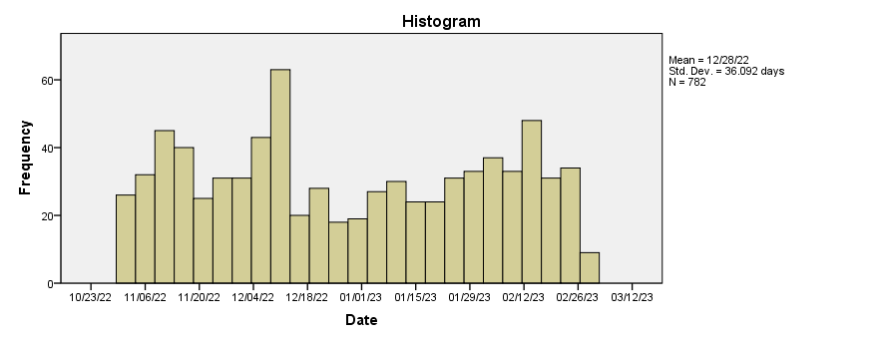

Figure 1. Distribution of posts over the considered period

Figures 2 and 3 present the distribution of posts considering the weekdays. We observe a slightly different pattern between the publishers investigated when considering the Facebook communication strategy. Litera posts more in the first half of the week, with a peak on Wednesday. Polirom prefers Fridays. Art Klett posts more on Tuesdays. All publishers do not post so much on weekends.

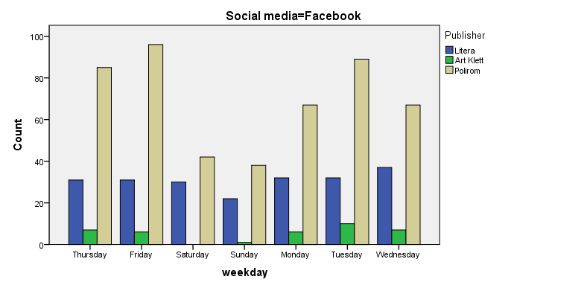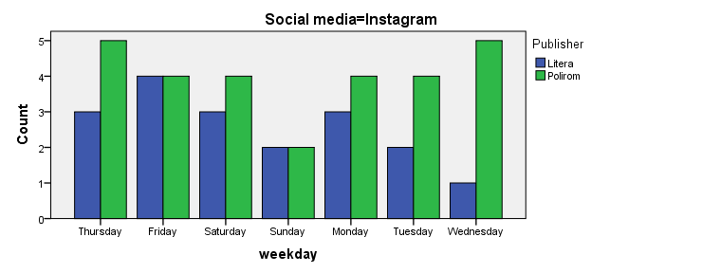Figure 2. Distribution of posts on Facebook, Figure 3. Distribution of posts on Instagram, by weekdays  
by weekdays

Content management

Most of the posts considered by the investigated publishers are book-related, as revealed in Table 5.

Table 5. Structure of the topics of the SM posts

|  |  |  |  |  |  |
| --- | --- | --- | --- | --- | --- |
| **Content** | | | | | |
|  | | Frequency | Percent | Valid Percent | Cumulative Percent |
| Valid | Book(s) presentation | 281 | 35.9 | 35.9 | 35.9 |
| Sales promotions | 136 | 17.4 | 17.4 | 53.3 |
| Social events | 40 | 5.1 | 5.1 | 58.4 |
| Author related info | 67 | 8.6 | 8.6 | 67.0 |
| Book review | 43 | 5.5 | 5.5 | 72.5 |
| Book related event | 145 | 18.5 | 18.5 | 91.0 |
| Publisher branding | 32 | 4.1 | 4.1 | 95.1 |
| Other | 38 | 4.9 | 4.9 | 100.0 |
| Total | 782 | 100.0 | 100.0 |  |

Not only the frequency of posts is relevant but especially their impact. Table 6 presents the statistics associated with the overall number of likes, comments, and shares. The variation is extremely high.

Table 6. Reactions to the posts on Facebook and Instagram

|  |  |  |  |  |
| --- | --- | --- | --- | --- |
| **Statistics** | | | | |
|  | | Likes | Comments | Shares |
| N | Valid | 782 | 736 | 733 |
| Missing | 0 | 46 | 49 |
| Mean | | 61.57 | 5.02 | 4.97 |
| Std. Deviation | | 175.659 | 60.529 | 37.329 |
| Minimum | | 0 | 0 | 0 |
| Maximum | | 2295 | 1300 | 791 |

As presented in Table 7, there are medium correlations between likes, on one hand, and comments and shares, on the other hand. The strongest correlation is between comments and shares.

Table 7. Bivariate correlation between likes, comments, and shares

|  |  |  |  |  |
| --- | --- | --- | --- | --- |
| **Correlations** | | | | |
|  | | Likes | Comments | Shares |
| Likes | Pearson Correlation | 1 | .475** | .538** |
| Sig. (2-tailed) |  | .000 | .000 |
| N | 782 | 736 | 733 |
| Comments | Pearson Correlation | .475** | 1 | .960** |
| Sig. (2-tailed) | .000 |  | .000 |
| N | 736 | 736 | 733 |
| Shares | Pearson Correlation | .538** | .960** | 1 |
| Sig. (2-tailed) | .000 | .000 |  |
| N | 733 | 733 | 733 |
| **. Correlation is significant at the 0.01 level (2-tailed). | | | | |

The analysis also presents some preferences for the type of knowledge presented in the posts. Overall rational messages predominate (almost 53% of all messages), followed by emotional ones (34%). The only publisher among the investigated ones which prefers emotional knowledge is Litera as presented in Figure 4.

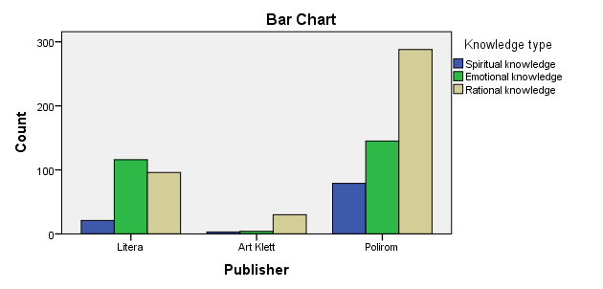

Figure 4. Frequency of knowledge-type posts, by publisher

The analysis revealed no significant correlation between the knowledge type distributed and the reactions of the public.

In terms of post types, the majority of posts are Photo+Text (94%), followed to a much lesser extent by Video+Text, Photo, and Text types. Notably, only Litera and Polirom have posted video content.

Overall, the content posted by the publishing houses is balanced and varied, especially on Facebook, which is their preferred platform for communicating with their audience. At the same time, each of the analyzed publishers seems to have a specific marketing strategy that aligns with their targeted audience and the image they want to project. Litera’s strategy is to project a more commercial and modern approach and relies more on promotional activities such as contests and discounts; they also provide information about new releases, existing books, as well as social events. They prioritize image and graphic design and focus on generating emotional responses from consumers. Art Klett is very niche and posts in accordance with their specialization, meaning the production of school-related books and didactic materials. At the same time, they engage in and organize events such as webinars for people employed in education, such as schoolteachers and other professionals. Polirom is more focused on presenting and discussing the books in its portfolio. They participate in professional competitions and have several initiatives aimed at educating the consumer. They also have the highest number of posts related to spiritual knowledge among the analyzed publishers. Adopting the role of educating the consumer is very important in the publishing industry, as it has deeper cultural implications.

It seems that the posts which receive the highest appreciation from the audience of each publishing house are the ones that align with the publisher's strategy. For instance, Litera's audience tends to appreciate posts related to contests, giveaways, and promotional materials, while Polirom's audience responds well to posts featuring their books or authors nominated for important awards. Art Klett's audience appreciates posts related to textbook presentations and educational webinars. Although emotional and spiritual knowledge seem to receive more likes, comments, and shares than rational knowledge in terms of top-performing posts, it does not necessarily translate into overall engagement. However, in the case of Art Klett, where the publisher needs to provide information in a rational and structured manner due to their specialization, rational knowledge prevails at all levels.

To be more precise, the top-performing post in terms of social media engagement on Facebook for Litera received 1100 likes, 1000 comments, and 791 shares. On Instagram, their most-liked post received 2295 likes. For Art Klett, the most popular post on Facebook obtained 53 likes, 12 comments, and 10 shares. Meanwhile, the number one post for Polirom on Facebook had 284 likes, 7 comments, and 34 shares. On Instagram, their most-liked post received 124 likes.

In terms of engagement, Litera has the highest level of engagement among the three publishers on both Facebook and Instagram, with their top three posts receiving the highest number of likes, comments, and shares. Two out of these three posts were contests organized by the publishing house. It seems that this type of content keeps the audience engaged, as people are willing to participate in contests with prizes and eager to find out the results. However, it's worth noting that this could be related to the higher number of followers that Litera has, with approximately 163,000 followers on Facebook and 36,600 followers on Instagram, which is significantly more compared to Polirom (26,000 followers on Facebook and 5,636 followers on Instagram) and Art Klett (12,000 followers on Facebook).

It is to be remarked that although the number of followers on Instagram for each publishing house (of the two that have a social media presence on this platform) is significantly lower than on Facebook, their posts receive approximately the same number of likes, and sometimes even more than on Facebook. This indicates the high potential of using this platform, and publishers should consider focusing more on Instagram to engage with their audience.

*Conclusions and implications*

Large commercial publishers are very active on Facebook, but not so visible on other social media platforms. The main approached strategy is to offer rational knowledge on books, followed by developing emotional links with their products. Distinct from a previous investigation which highlighted the important role of sales promotions in the communication strategies of Romanian publishers (Zbuchea and Mocanu 2013) the present investigation shows that Sales promotion is a vector, but not the most important mechanism used by these publishers to attract their clients. As culture is a deeply social aspect, and book publishing is a vital part of the cultural sector, it would be beneficial for publishers to place more emphasis on spiritual knowledge in their communication with actual and potential customers. This could help educate the consumer and foster a healthier relationship with the culture itself. Examples of this kind of approach could include providing more information about classic authors, promoting social events, showcasing artistic and cultural endeavors, and highlighting historically significant information that would resonate with the targeted audience.

To attract a younger audience, it would be beneficial for publishers to be also more active on other social media platforms used in Romania, such as Instagram, TikTok, and LinkedIn. It's worth noting that on Instagram, the number of likes on publishing houses' posts is quite high compared to their overall activity and effort put into posting on this platform. Publishers' names are widely used as hashtags on Instagram and TikTok, and there are book influencers with a significant number of followers, indicating the potential of these platforms. However, publishers should align their posting strategy with the algorithms of these platforms, for example, posting more reels to gain visibility or sharing stories multiple times a day to keep the audience engaged. Having a presence on LinkedIn would also be advantageous, as publishers could gain more visibility as employers and use the platform to share opinions on social issues and information about their brand, events, and accomplishments. Twitter, on the other hand, is not widely used in Romania. The publishing houses could create an account on this platform and post a few times a week to maintain their presence there. Publishers could benefit from a more efficient approach to their social media activity by posting on a wider range of social networks and automating repetitive tasks through specialized software. These tools allow for scheduling posts in advance, maintaining consistency, and posting the same message on multiple platforms simultaneously. They can also aid in monitoring for mentions and providing statistical analysis on engagement levels and opportunities for improvement.

To conclude, although there is scope for development in the social media approaches employed by publishing houses in Romania, they have effectively designed strategies and demonstrated consistent activity, at least on one platform. They maintain their online presence and professionally engage with their audience. It is crucial to sustain this trend of online engagement with consumers to stay competitive and achieve success. In today's world, an online presence is almost imperative for the well-being of businesses across all industries. In the publishing industry, which is highly dependent on customers' needs, wants, and preferences, this type of connection is critical and must be nurtured and enhanced.

*Literature*

Fatima Ahmed Almazrouei, Muhammad Alshurideh, Barween Al Kurdi, Said A. Salloum (2021): Social Media Impact on Business: A Systematic Review. In Aboul Ella Hassanien et al. (eds.) Proceedings of the International Conference on Advanced Intelligent Systems and Informatics 2020. AISI 2020. Advances in Intelligent Systems and Computing. Switzerland: Springer International Publishing AG, 697–707. <https://doi.org/10.1007/978-3-030-58669-0_62>.

Carmen Balan (2015): Marketing Trends in the Online Retailing of Books in Romania. International Conference on Marketing and Business Development, 1(1), 218-226.

Petre Barbu (2022): Top 101 edituri din România cu bilanțurile financiare în anul 2021. Forbes, June 22. https://www.forbes.ro/top-101-edituri-din-romania-cu-bilanturile-financiare-in-anul-2021-271190

Alison Baverstock, Susannah Bowen (2019): How to Market Books. New York: Routledge.

Ettore Bolisani, Constantin Brătianu (2018): Emergent Knowledge Strategies. Strategic Thinking in Knowledge Management. Switzerland: Springer International Publishing AG.

Constantin Brătianu (2015): Gandirea Strategica. Bucharest: Editura Pro Universitaria.

Constantin Brătianu, Bejinaru Ruxandra (2019): The Theory of Knowledge Fields: A Thermodynamics Approach. Systems, 7(2), 20-32.

Giles Clark, Angus Phillips (2019): Inside Book Publishing. New York: Routledge.

Marian-Gabriel Hâncean, Iulian Oană (2018): Consum cultural non-public. In Carmen Croitoru, Anda Becuț Marinescu (eds.): Barometrul de Consum Cultural 2017. Bucharest: Editura Universul Academic, 169–205.

Bogdan Hrib (2018): Editor de unul singur. Management in industria cartii. Bucharest: Tritonic.

Bogdan Hrib (2020): Books in Time of Pandemia: Romania, One Way Again – From Paper to Internet? In Rodica Pamfilie et al. (eds.) 6th BASIQ International Conference on New Trends in Sustainable Business and Consumption. Bucharest: Editura ASE, 1042-1048.

Daniel Kahneman (2012): Thinking, Fast and Slow. New York: Farrar, Straus and Giroux (FSG).

Pin Luarn, Yu-Fan Lin, Yu-Ping Chiu (2015): Influence of Facebook brand-page posts on online engagement. Online Information Review, 39(4), 505-519. <https://doi.org/10.1108/OIR-01-2015-0029>.

Sarhang Majid, Carmen Lopez, Phil Megicks, Wai Mun Lim (2019): Developing effective social media messages: Insights from an exploratory study of industry experts. Psychology & Marketing, 36(6), 551-564. <https://doi.org/10.1002/mar.21196>.

Joe Mosca, Kevin P Curtis (2019): New Approaches to Learning for Generation Z. Journal of Business Diversity, 19(3), 66-74. DOI:10.33423/jbd.v19i3.2214.

Sybil Nolan, Alexandra Dane (2018): A sharper conversation: book publishers’ use of social media marketing in the age of the algorithm. Media International Australia, 168(1), 153–166. <https://doi.org/10.1177/1329878X18783008>.

Ikujiro Nonaka, Hirotaka Takeuchi (1995): The Knowledge-Creating Company: How Japanese Companies Create the Dynamics of Innovation. New York: Oxford University Press.

Ikujiro Nonaka, Zhichang Zhu (2012): Pragmatic Strategy: Eastern Wisdom, Global Success. Cambridge: Cambridge University Press.

Laurence O'Bryan (2019): Social Media is Dynamite - How to Get Noticed and Sell More using Social Media. Independently published.

Jacob Dahl Rendtorff (2019): Philosophy of Management and Sustainability: Rethinking Business Ethics and Social Responsibility in Sustainable Development. Bingley: Emerald Publishing Limited. https://doi.org/10.1108/978-1-78973-453-9201910062.

Claire Squires, Helena Markou (2021): An Ecosystem Model of Small and Medium Sized Enterprises Publisher ‘Tiers’: Publisher Size, Sustainability and Cultural Policy. Publishing Research Quarterly 37(4), 420–438. DOI:10.1007/s12109-021-09811-y.

Nassim Nicholas Taleb (2012): Antifragile. Things that gain from disorder. Manhattan: Random House.

Helmi Tukia (2022): The role of book content and influencers on TikTok in marketing of books. [Bachelor’s Thesis, Lappeenranta–Lahti University of Technology LUT]. LUTPub. https://lutpub.lut.fi/handle/10024/165072.

Alexandra Zbuchea, Bogdan Hrib (2019): How to Sell a Book? Insights from Romania. Management Dynamics in the Knowledge Economy, 7(3), 423-438. DOI 10.25019/MDKE/7.3.09.

Alexandra Zbuchea, Rareș Mocanu (2013): Adding Value to Customers and Developing Brands through Electronic Newsletters. Economia. Seria Management, 16(2), 297-315.