The Return of Geopolitics: Empty UN Principles and Agreements Overlooking Geostrategic Thinking

PALADE Brîndușa

National University of Political Studies and Public Administration, Bucharest (Romania)
brindusa.palade@politice.ro

Abstract

The military crisis in Ukraine that began with the invasion of Russia on February 24, 2022 and the violation of many international principles of military conflict by the Russian Army, together with the energetic reshuffling of Western European countries against this well-armed rogue state have brought back the importance of geopolitics in a way almost as intense as during the Cold War. UN principles such as R2P (“responsibility to protect”) or Western promises to reduce carbon emissions have appeared empty when the military concern to avoid a larger scale conflict was embraced by many NATO allies as a priority. Furthermore, the energy dependence of some Western countries like Germany on the Russian gas imports by ignoring geostrategic realities has proven a liability, given the obvious Russian expansionism and its military and political efforts to destabilize the international order. This paper will try to propose a balance between high-minded international moral principles and geopolitical realism, with the aim to suggest ways in which institutions that adopt such norms and principles cannot be blocked by the political “inclusion” of actors that do not adhere to them. The UN Security Council, for example, should not have permanent members that violate human rights and international laws. Climate projects to reduce carbon emissions should take into account more variables than economy and environment, while not relying on a rather utopian peaceful cooperation between countries like Russia or China and Western and Central European states.

Keywords: geopolitical thinking, moral principles, international order, utopianism

Introduction

The global liberal order after World War II has been designed according to an ideal of "universal peace" that was famously enshrined into the first Article of the UN Charter [1]. This ideal echoes the Kantian political goal of "perpetual peace" [2], though the way in which it was asserted after World War II was not through rational philosophical reflection on what would be best for humankind. Instead, after the tragic experience of two destructive world wars driven by expansionist willpower and irrational nationalistic cults, the order was imposed as imperative international norms.
Nevertheless, the very architecture of the United Nations has mainly rewarded the powers that prevailed after World War II, which explains why there are still five permanent members of the UN Security Council that enjoy the right to veto any decision, according to Article 23 of the UN Charter [3]. Among them is Russia, the current aggressor and violator of post-WWII international laws and conventions in Ukraine that uses its status as a platform for its propaganda and as a means to block any significant action by the UN to put an end to the slaughtering of innocent civilians.
As of June 2022 the UN diplomacy in Ukraine looks like a rather pointless conversation about the high-minded principles and ideals of the Charter. On May 6, 2022, the UN Security Council unanimously voted for a resolution expressing its "firm support" to "the search for a peaceful solution" in Ukraine, but the semantics may differ in the interpretation of a "peaceful resolution" of the conflict by Russia and the Western countries. Russia's first permanent deputy representative to the UN Dmitry Polyanskiy has pointed out that from the Russian perspective there is no contradiction between "asking for peace" and the objectives of Russia's "special military operation" in Ukraine. In fact, he claimed that "the operation was started with the objective of establishing peace" [4].
On another level of global ethical concern, namely the anthropogenic effect on climate change and the action needed to prevent catastrophic consequences for future generations through sustainable alternatives to fossil fuels, until the beginning of 2022 the conversation has once again been oblivious of the need to take into account geopolitical realities. Indeed, geopolitical thinking was often neglected as an obsolete concern during COP agreements that were more focused on progressive climate targets than on realistic considerations about rogue countries which export fossil fuels to EU members, while spending a large budget on buying weapons and maintaining their capabilities of mass destruction. Focusing on sustainable development through environmental policies that prioritized a global "green" economic growth, Western leaders did not appear to consider that other countries may have different priorities.
After the barbaric Russian invasion of Ukraine in 2022 it is clear even for polite Western idealists that an utopian global order that postpones geopolitical thinking provides opportunities and time to brutal dictators to build military power that can be later used to commit atrocities against civilians, as the Western world keeps entertaining peaceful "green" projects.
While this paper supports clean energy with zero carbon emissions, it also argues that without taking into consideration geopolitical realities, the "green" conversation can be as useful as the one about the force of the right within global institutions in which believers in the right of force have the power to block every action that goes against their interests.
Granted, the UN's humanitarian interventions are usually more successful than its attempts to prevent new atrocities around the world. But this achievement can match the objectives of a prestigious international NGO, rather than the goals of an institution with lofty principles enshrined in a document like the UN Charter.

The UN Responsibility to Protect after the Russian invasion of Ukraine

The UN doctrine of Responsibility to Protect (R2P) is a commitment of the member states to "end the worst forms of violence and persecution" [5] that was set up in 2001 by the Canadian government. Following the atrocities of Srebrenica and Rwanda in the 1990s, the UN asserted a "residual responsibility" of the international community to protect people from crimes or atrocities which supplements the primary responsibility of the state to protect its own citizens. In other words, when a state is unable to fulfill the obligation to protect its citizens or is the actual perpetrator of crimes, the members of the United Nations are supposed to intervene for humanitarian purposes. Such interventions are primarily intended for preventing further crimes. They aren't only humanitarian reactions to crimes that are being committed in front of a powerless global community.
Most diplomatic efforts of the UN to persuade Russia to stop its brutal invasion of Ukraine, such as the meeting between the UN Secretary-General Antonio Guterres and the Russian president Vladimir Putin in April 2022, have not been fruitful. Russia has continued its indiscriminate killings and did not put an end to its other atrocities (rapes, torture, deportation of children and civilians). So, in front of the most barbaric European invasion of our time, the UN efforts to bring peace and restore the safety of civilians caught between combatants were only limited to ineffective diplomacy.
Another consequence of the illegal Russian invasion is that the blockade of Ukrainian ports may trigger a global food crisis, especially in most vulnerable developing countries from Africa and Asia. This is another sensitive topic for the UN, whose mission, assumed by its Food and Agriculture Organization, is also to protect food security around the globe. Given the rising prices for food, especially wheat, that are caused by the war between two of the world's largest grain exporters, the crisis may harm more people than the afflicted Ukrainians who are the direct target of the aggression.
Furthermore, Russia may try to use this consequence of the war as a leverage to negotiate an unjust compromise with regard to occupied areas of Ukraine. Once again, its position as a permanent member of the UN Security Council is an awkward diplomatic privilege for a country that endangers and impoverishes so many people around the world.
After the failed mission of the UN to protect Ukrainian citizens from the Russian aggression, it seems obvious that as long as an aggressor state may veto any significant decision related to the safety of civilians from the crimes committed by its own military there is little hope for the R2P principle to be anything but hollow [6]. The UN's dilemma is not just confined to the realistic hopes that the R2P doctrine may be applied in similar conditions. It also concerns its basic ideal of promoting peace around the world.
This dilemma seems to derive from the philosophical predicament of idealism in an international environment in which rogue states try to restore their lost empires by nefarious means. To this we may add the legal issue that by enshrining the post-WWII order into the Charter (Article 23) the UN has perpetually empowered five permanent members [3] whose actions are therefore almost unaccountable in the Security Council.

Energy dependence and the return of geopolitics in Germany

The geopolitical thinking of the Cold War period in which the Eastern bloc was isolated from Western capitalist democracies, not only in terms of ideology and politics, but also by limiting commodities and energy deals, was clearly abandoned in the post-Cold War era by European leaders like Gerhardt Schroeder and Angela Merkel. After the Russian invasion of Ukraine in February 2022, the extent to which former Chancellor Merkel has made Germany captive to Russian energy exports was widely regarded as an European geopolitical error. According to Deutsche Welle, at the beginning of 2022 Germany imported from Russia 55% of its total gas imports, about 50% of its hard coal imports and 30% of its oil imports [7].
Maybe the most surprising political reaction to Russian forces starting a brutal war of aggression in the neighboring Ukraine was that of Chancellor Olaf Scholtz, who on February 27, soon after the war started, announced not only a major increase in the German defense spending, but also a paradigm change in Germany's foreign policy [8]. The old paradigm was the politics of détente promoted by the former Chancellor Willy Brandt towards Eastern Europe, which was known as Ostpolitik. That was aimed first and foremost at improving relations between West and East Germany (former GDR), but it also favored pragmatic relations between West Germany and the Soviet Union, notwithstanding the latter's notorious human rights violations.
After the end of Cold War, Germany increased its economic dependence on the energy exports from Russia and its diplomacy generally reflected this policy. As we will see below in much detail, Germany has also powered down three of its six nuclear plants by the end of 2021 and has plans to shut down the remaining three plants by the end of 2022. That only increased its energy captivity to Russian exports.
However, after the Russian invasion of Ukraine in 2022, these plans that were initially devised by the Merkel government in wake of huge anti-nuclear protests after the 2011 Fukushima nuclear accident, have been called into question. Since Germany can no longer rely safely on Russian gas, for obvious geopolitical reasons, the leading economists from the German Council of Economic Experts have suggested that the shutdown of the active reactors should be delayed [9].
So far, however, the plan to power off the three active nuclear plants and to exit nuclear power seems to be still endorsed by the government as the correct decision, given the strong anti-nuclear orthodoxy in Germany.
The German anti-nuclear movement usually conflated the use of nuclear energy with war and the atomic bomb and had pacifist undertones. There was also a fear of increased radioactivity that might affect children playing outside. So, for cultural and political reasons, as well as risk aversion, the German plan to exit nuclear power will probably be executed.
Germany also intends to extend its solar and wind plants, in order to reach energy independence in sustainable ways and thus attain the goals set up by the COP 21 Paris Agreement on climate change. We will come back to this project of extending renewables in a section below.

Utilitarian benefits of nuclear technology

Utilitarianism or consequentialism was criticized, for example by G. E. M. Anscombe, as a doctrine that is not only philosophically shallow, but also hard to support on ethical grounds, because it may justify evil actions such as the killing of innocents [10]. More recently, in A Theory of Justice, John Rawls has argued that utilitarianism can be reduced to profit maximization and that it fails to separate persons and consider justice for individuals [11].
The case made by Anscombe against the utilitarian atomic bombings by the US Air Force at the end of World War II and the honouring of president Harry Truman by the University of Oxford in 1956 is a strong classic illustration of the dangers of consequentialism for non-combatants during a war [12]. However, even if one endorses Anscombe’s high-minded moral principles and her arguments against the use of nuclear weapons during World War II, this bears virtually no relation to an argument for producing nuclear energy in the contemporary world, for the simple technical reason that in a nuclear reactor the power is generated over a period of time, whereas in a nuclear weapon all the energy is destructively released in an instant.
Nuclear accidents like Chernobyl, the catastrophic explosion of an entire nuclear reactor in the former Soviet Union, and Fukushima, the more recent nuclear disaster caused by a tsunami wave in Japan, are of course testimony to the risks involved by nuclear technology. But given the fact that the potential benefits far outweigh the risks, there is still room for endorsing nuclear energy on utilitarian grounds. If we also consider that the death toll of air pollution is annually over 4 millions, whereas the total known death toll of nuclear energy is a little over one thousand people, we may have further consequentialist reasons to support nuclear projects [13].
But the more compelling environmental argument in favor of nuclear energy is its zero-emission sources that may leave very little waste. Nuclear power plants provide electricity that is entirely carbon neutral. If European countries are committed to drastically reduce their carbon emissions in the near future, their current tendency to discard nuclear technology as dangerous seems rather inconsistent.
If adequate security is provided for nuclear reactors, and the protocol for dealing with radioactive sources is carefully observed, there is no need for environmental alarm and even less for apocalyptic scenarios of a nuclear doomsday [13, p. 173].

Nuclear power plants vs. renewables in Germany

At a global level, the world expenditure for nuclear between 1965 and 2018 has been about 2 trillion USD, and the costs for solar and wind energy over the same period of time has been around 2.3 trillion USD. As a result of this global experiment, the world received twice as much from nuclear energy than from solar and wind [13, p. 154]. In addition, solar and wind energy require batteries that only last between 5 and 15 years and afterwards generate toxic waste which can contaminate rivers or soil.
Renewable energy is also less efficient and often unpredictable, depending on natural phenomena such as sunshine and wind. The fact that, despite its large investments in solar and wind farms, a country like Germany that is committed to an Energiewende still relies on fossil fuels and natural gas, as it is clear from the below chart [14], is very significant.
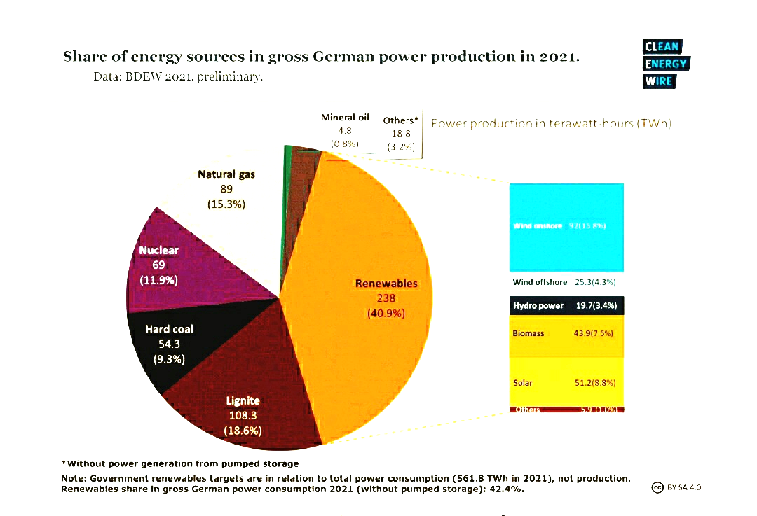

Figure 1. Source: Clean Energy Wire

The nuclear energy that was still available in Germany in 2021 (11.9 % of the total energy sources) was relying on three nuclear plants – Emsland, Isar and Neckarwestheim – that are to be powered down in 2022 [15]. Unlike France, Germany is reluctant to call nuclear energy “green” because of its particular cultural phobia of anything related to the atomic bomb.
Beside the lack of energy efficiency of renewables, a further issue regards the solar panel disposal after being discarded. Many photovoltaic panels are disposed of rather than recycled, because recycling is a very expensive process. Most of the waste goes to poorer or developing nations whose governments are often ill-equipped to deal with this burden so as to not pollute the environment. Middle Eastern countries usually prefer to buy cheaper second hand solar panels rather than invest in brand-new ones [13, p. 189].
If we employ an utilitarian or a cost-benefit analysis on the global level, we can see that the waste resulting from the disposal of photovoltaic panels could increase the percentage of solar panels' waste in the global electronic waste, which is by no means a "green" energy strategy that benefits humankind as a whole.
As for Germany, the computer scientist Rainer Klute who founded Nuklearia, an organization that advocates for nuclear energy in Germany as an environmental alternative to fossil fuels, relies on more recent polling that shows a shift in the German public's perception of the environmental benefits of nuclear technology. According to some surveys, the war in Ukraine and the energy dilemmas that have arisen in such circumstances have apparently led to an increased enthusiasm for using nuclear power to meet climate targets. According to Klute, even the staunch resistance of the German Green party to nuclear energy, that was its foundational policy, has diluted after the Russian invasion of Ukraine [9].

Nuclear sources of electricity in France

As per the national statistics provided by the EDF in the chart below [16], in 2019 the nuclear sources of electricity in France represented 70.6 % of the total energy production.

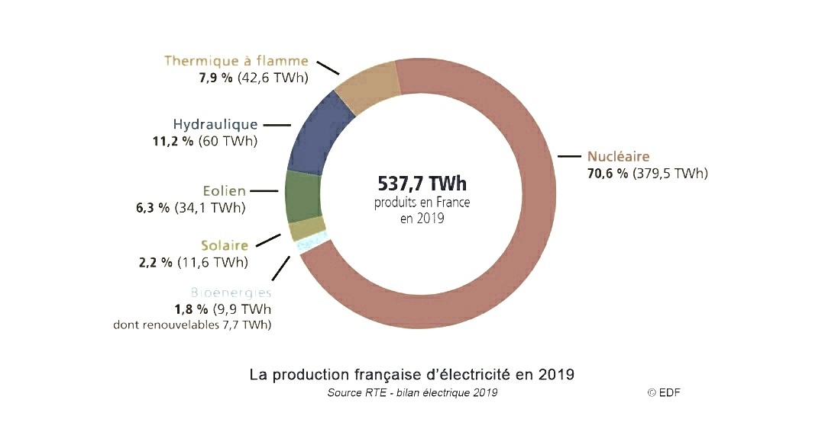

Figure 2. Source: EDF

We can notice that the percentage of solar and wind energy is only 8.5 % from the total production in 2019. A more significant percentage of 11.2 % comes from hydraulic sources. The energy based on fossil fuels is only 7.9 % of France's energy sources, whereas it represents 40 % of Germany’s overall energy production (in 2021). The obvious conclusion is that France is doing much better than Germany in terms of cutting carbon emissions as it mostly uses more reliable nuclear and hydraulic sources of energy than solar and wind.
The French government's decision to expand even more its nuclear capabilities by building six new nuclear reactors in the future is the main current strategy of this country to reduce greenhouse gas emissions [17]. This move also comes amid concerns about the dependence on global gas and oil exporters, which have understandably increased after the European economic sanctions against Russia in 2022.

The European politics of gas imports

The liberal utopianism of a global market that benefits every country in a peaceful world has been overwhelmingly questioned after Russia's aggressive attempts, which became more brutal in 2022, to use the leverage of its gas exports to Europe in order to impose a new international order. And although China has chosen to become a top global player by economic means and so far didn't seem to plan a widespread war of aggression, its proximity to Taiwan and its hostility to the flourishing democracy in the neighboring country have raised concerns about a possible willingness of Beijing to take a page from Moscow and try to occupy Taiwan in the near future.
The main issue that has become obvious in early 2022 is that the liberal energy policies of Europe that have abandoned the former Cold War-era geopolitical approach, while normalizing "doing business" with Russia, were a mistake.
The map of "reliable countries" that can be a part of business contracts in accordance with a new "Cold War geopolitics'' is clearly more complicated than the previous one. The latter was drafted through a liberal optimistic lens, but had also a strong economic rationale that was consistent with global market utopianism. It was of course more advantageous for the German economy to purchase cheaper Russian gas than to find more expensive alternatives for its energy consumption.
Under the influence of the German policy of Gerhardt Schroeder and Angela Merkel that strongly favored Russia's energy exports, other European countries, especially in Eastern and Central Europe, have coordinated their energy policy with the German one and eventually became highly dependent on Russian gas too. According to the Statista Research Department, in 2020 Russia was the extra-UE exporter of over 43% of gas imports to European countries [18].
The embarrassment is even more serious since, as The New York Times reminds us, both Schroeder and Merkel have refused to do mea culpa [19]. The conventional justification for European trade with Russia was that it had the potential to placate this country and prevent it from risking a larger conflict in Europe that would jeopardize its profits.
The economic advantage in the German-Russian relationship has been mutual. But the fact that it has enabled Russia to pursue its aggression in Ukraine has not been seriously considered, even if the war in Ukraine had actually started on a smaller scale in 2014. The Merkel government has carried on with its pragmatic policy of boosting the German economy by importing cheap Russian gas. Other European countries have followed suit.
Apart from France, that follows a different model mostly based on nuclear power, up until 2022 much of the European politics of gas imports has been devoid of geopolitical concerns over the degree to which this very politics allowed Russia to increase its military spending and to continue to go after territories from the former Soviet empire.

Sabotage-proofing nuclear plants is necessary

As I began writing this paper, the Chernobyl power plant located to the north of Kyiv was captured by the Russian military that invaded Ukraine in February 2022. Such unsettling news may provoke a broader reflection on how rules that have preserved the international order and the relative peace in Western countries after World War II can be subverted by dictators who rule by force and want to rebuild empires. Such malevolent leaders may try to seize vulnerable spots such as the nuclear plants and use them for blackmailing the civilian population into submission to foreign invaders. Alternatively, terrorist groups or individuals may attempt to sabotage nuclear reactors.
These are possible dangers that can only be prevented through high security involving the military. Below is an example of the security around a typical French nuclear plant, as per the EDF [20].

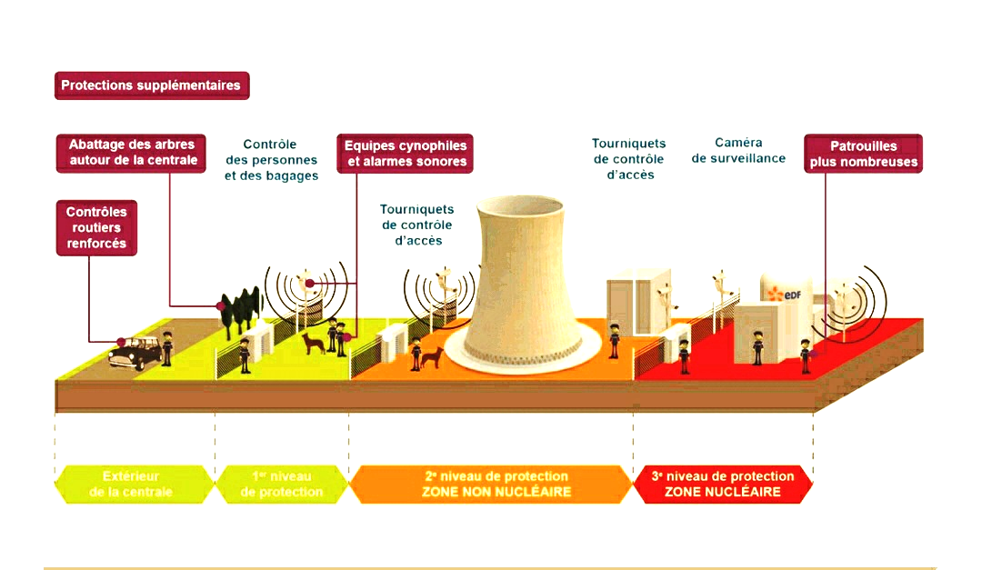

Figure 3. Source: EDF

There are four levels of security, three of them being installed in non-nuclear areas surrounding the plant. This does not suffice, of course, if the nuclear plant is located into a war zone and if aggressive armed forces try to seize control of the nuclear reactors. However, such aggressors need to be wary of radioactive dangers. As the Chernobyl case shows, in 2022 the Russian military that occupied the spot of the former nuclear accident without wearing appropriate gear and had camped out for weeks in a radioactive forest nearby the nuclear plant may have been exposed to high levels of radiation [21].
While there are no perfect security warrants for nuclear reactors, the cost-benefit analysis in terms of clean and stable energy shows that they are usually a better option than unstable electronically powered renewables that create further waste.

Better options preferable to the best possible scenarios

At this point, we may endorse a philosophical attempt to moderate idealism and the delusional expectation of the best possible scenarios. A fully harmonious set of values and optimal solutions may of course expand the political imagination. However, if it isn't backed by more down to earth problem solving it might be either impracticable or potentially harmful.
As an example, setting the post-WWII order as the foundation of the United Nations has simply ignored the ancient warning of the Greek philosopher Heraclitus that change is inescapable. Granting the nations that have contributed to peace decades ago some perennial diplomatic advantages over other nations has reiterated the old utopian desire that somehow all challenges to human society and international peace be answered with the same static solution.
Utilitarian ideas or solutions can sometimes be amiss, since they may involve difficult compromises or sacrifices, as Anscombe has pointed out [10]. However, as the liberal philosopher Isaiah Berlin has noticed in an essay about utopias, they are often more capable of maintaining a precarious equilibrium of human society that prevents worse outcomes [22].
In conjunction with this, geopolitics is far from being unchangeable and old alliances may become incongruous with new international developments. Or else, former great powers may change their rhetoric and "values". For example, in June 2022, months after starting the Ukraine invasion, Russia's President Putin has shifted from his nostalgia of Soviet-style imperialism to an ostensible historic mission of rebuilding the Russian empire established by the Czar Peter the Great in the early 18th century [23]. To force the irony, should the UN consider reserving permanent membership in the Security Council for the new Russian empire as well?
Other nations that were former opponents to the Western alliance in World War II and have been defeated, such as Germany or Japan, have become its strong allies in a different international setting. Geopolitical thinking must therefore be dynamic, anti-utopian and priority-driven. An utilitarian moral philosophy is better equipped to provide guidelines to such geopolitical considerations than the kind of static idealism that was crucial for the UN foundation in 1945. Even if some utopian ideals, such as peace and security for all nations or a green environment that leaves a biodiverse planet to future generations are attractive frontiers of political imagination, it is clear from the diplomatic ineffectiveness of the UN after the Russian invasion of Ukraine and Germany's failure to cut carbon emissions that relying on such ideals alone is impractical in a power-driven, highly competitive international environment.
In the current circumstances, energy independence is more important for European nations than relying on a global trade that empowers rogue countries that harbor imperialistic ambitions and disdainful attitudes to international laws. And if nuclear power is a better option than renewables to secure this energy independence, it is clearly more beneficial to Europe to expand it while sabotage-proofing all nuclear facilities in order to prevent future attempts to hijack or convert them into war machinery.

The bottom line: balancing idealistic norms with geopolitical realities

The wake-up call of the 2022 Russian invasion of Ukraine has galvanized a return to geopolitics in most European policies aimed at security and energy production. It has also brought into question the effectiveness of institutions like the UN Security Council, which has permanent member states that violate human rights, and at least one member which defies international laws and uses its status as a platform for propaganda.
Such diplomatic privileges bestowed upon countries like Russia or China prevent for example the approval of a peace mission that could protect civilians in Ukraine, as they clearly belong to outdated geopolitical circumstances. If the UN is not to contract into a more prestigious international NGO, its current structure should be updated in agreement with present geopolitical realities. Post-WWII international norms and principles have been a moral progress of humankind, but given the current blockage in the UN Security Council, a UN doctrine that was meant to protect civilians like R2P tends to be devoid of any realistic meaning. So appears to be the very first Article of the UN Charter.
A non-utopian design of an international institution that is meant to protect peace and security worldwide should therefore be inherently flexible and dynamic, as opposed to statically preserving the post-WWII establishment. An international order based upon high-minded ethical norms and principles has normative value. But such order can become meaningless if it doesn't allow an "incompatible" utilitarian approach or some realistic precautions to prevent worse consequences of human actions and to keep dissenting groups from inflicting too much mutual harm [22, p. 48].

REFERENCES
1. United Nations (1945). Charter of the United Nations. First Article. Retrieved from
https://legal.un.org/repertory/art1.shtml on June 21, 2022
2. Kant, I. (2006). Toward Perpetual Peace and Other Writings on Politics, Peace, and History. Edited by Pauline Kleingeld, Yale University Press, New Haven and London, pp. 67-80.
3. United Nations (1945). Charter of the United Nations. Article 23. Retrieved from
https://legal.un.org/repertory/art23.shtml on June 21, 2022
4. Nooten, C. (2022). The Beginning of a Resumption of UN Diplomacy. Le Monde, May 8. Available at
https://www.lemonde.fr/en/international/article/2022/05/08/war-in-ukraine-a-beginning-of-a-resumption-of-un-diplomacy_5982759_4.html Accessed on June 20, 2022
5. United Nations (2005). Responsibility to Protect. Available at
https://www.un.org/en/genocideprevention/about-responsibility-to-protect.shtml Accessed on June 21, 2022.
6. Lee, P. (2022). Ukraine: The UN's "Responsibility to Protect" Doctrine Is a Hollow Promise to Civilians under Fire. The Conversation, (March 7)
7. Deutsche Welle (2022), Ukraine crisis forces Germany to change course on energy. (March 1)
8. Deutsche Welle (2022), German Chancellor Olaf Scholtz announces paradigm change in response to Ukraine invasion. (February 27)
9. Meakem, A. (2022). Germany Confronts Its Nuclear Demons. Foreign Policy, (June 20)
[10] Anscombe G.E.M. (2005), Human Life, Action and Ethics. Edited by M. Geach and L. Gormally. Imprint, Exeter, pp. 181-185.
11. Rawls, J. (1999). A Theory of Justice. Oxford, Oxford University Press, pp. 24-25.
12. Anscombe, G. E. M. (1956). Mr Truman's Degree. Retrieved from https://www.law.upenn.edu on June 21, 2022.
13. Schellenberger, M. (2020). Apocalypse Never: Why Environmental Alarmism Hurts Us All. HarperCollins, New York, pp. 152-153.
14. Clean Energy Wire (2022). Available at https://www.cleanenergywire.org/ Accessed on February 24, 2022.
15. Country Nuclear Power Profiles: Germany (2021). Available at
https://cnpp.iaea.org/countryprofiles/Germany/Germany.htm Accessed on June 22, 2022
16. EDF (2020). La production française d'électricité en 2019. Available at https://www.edf.fr/ Accessed on February 24, 2022.
17. France 24 (2022). Announcing new reactors, Macron bets on nuclear power in carbon-neutral push. (February 10). Available at
https://www.france24.com/en/europe/20220210-announcing-new-reactors-macron-puts-nuclear-power-at-heart-of-carbon-neutral-push Accessed on June 22, 2022
18. Statista (2021). Dependence on Russian gas in Europe 2020, by country. Available at
https://www.statista.com/statistics/1201743/russian-gas-dependence-in-europe-by-country/ Accessed on May 11, 2022.
19. Bennhold, K. (2022), Gerhardt Schroeder, The Former Chancellor Who Became Putin's Man in Germany. The New York Times, (April 23)
20. EDF (2022), La sécurité autour des centrales nucléaires. Available at
https://www.edf.fr/groupe-edf/espaces-dedies/l-energie-de-a-a-z/tout-sur-l-energie/produire-de-l-electricite/la-securite-autour-des-centrales-nucleaires Accessed on June 22, 2022
21. Kramer, A. E. (2022). Russian Blunders in Chernobyl: "They Came and Did Whatever They Wanted". The New York Times, (April 8)
22. Berlin, I. (1990). The Crooked Timber of Humanity: Chapters in the History of Ideas. John Murray, London, pp. 17-18.
23. Troianovski, A. (2022). Putin the Great? Russia's President Likens Himself to Famous Czar. The New York Times, (June 9)

