“As Long As It takes.” An Analysis of the Discourse and Policies of the Biden Administration during the First Year of War in Ukraine
Iulia Huiu

Even before Russia’s aggression against Ukraine, at least two concurrent challenges presented themselves in the international arena: an increased geopolitical great power competition and a set of new transnational shared threats, like climate change, pandemic, or terrorism. Whether the world finds itself now, a year into the war in Ukraine, at a “inflection point”, or “between orders”, there is a commonly shared belief both among international relations scholars and policy makers that today’s events are going to prove decisive for the decades to come. Inside of this geopolitical struggle, United States has been reaffirming its stance in the world, and centered its new National Security Strategy, issued in October 2022, around the need for US leadership in the “strategic competition to shape the future of the international order.” With the war in Ukraine, the focus of US foreign policy has shifted during the last year to put an increased emphasis on Eastern Europe. Despite facing some criticism at home, both at the beginning of the war for not taking even more decisive actions, and lately from the far-right opposed to more funding, the US support for Ukraine has been consistently bipartisan in Congress and has benefited from large public approval. US has provided almost $25 billion military assistance to Ukraine since the beginning of the Biden administration and has vouched to support Ukraine “as long as it takes”. The aim of this paper is to use the qualitative tool of discourse analysis to identify the main themes of US foreign policy in regard to Ukraine, how they translated into actions during the first year of war and what this could mean for the future of US interests in the region.

Key words: war in Ukraine, US foreign policy, discourse analysis, Eastern Europe, Biden administration

Author description: Iulia Huiu is a PhD candidate in Political Science/ International Relations at the National University of Political Studies and Public Administration (SNSPA). Between 2017 and 2022 she served as a diplomat at the Embassy of Romania to the US in Washington DC, where she had extensive experience with American politics and foreign policy, including working with Congress. Prior to this, between 2014 and 2017 she was State Advisor to the President of Romania. Starting February 2023, Iulia Huiu teaches “American Politics and Foreign Policy” at the National University of Political Studies and Public Administration. She co-authored two books analyzing Romanian post-communist politics.

Introduction

The geopolitical world has changed. The brutal invasion of the sovereign Ukraine by Russia and the war that ensued made this change obvious and brought it to a whole new level. As Richard Haas put it, the world seems to be inside of “a perfect storm”. Even before the war in Ukraine, we witnessed the rise of authoritarianism and democratic backsliding globally, the re-emergence of old geopolitical risks of the great power competition, colliding with new ones like climate change or pandemics (Haas, 2022, p. 26) . On February 24, 2022, Russia invaded Ukraine, starting thus a chain of events that are still unfolding. Where do they lead is still uncertain, however we can say with certainty this war has posed a threat to the international rule-based order, has challenged long held beliefs or policy positions, and has determined unprecedented actions. It has already re-shaped how states - Great Powers or not - view the international arena and assess threats, how they react and prepare, and it will most likely continue to shape national security strategies, foreign policy doctrines and political decisions.
This is a milestone geopolitical event, the kind of historical event there is no turning back from. There is already a world “before the war in Ukraine” and another one after. Fiona Hill, one of the most prestigious analysts and scholars specialized in Russia, was unequivocal in her evaluation on the war in Ukraine and its significance: “This is a great power conflict, the third power conflict in the European space in a little over a century…It’s the end of the existing world order. Our world is not going to be the same as it was before.” (Reynolds, 2022).
On the flipside, before the war in Ukraine, NATO was in the process of redefining itself, after its purpose and even mere existence had been questioned by former US President. Now NATO is stronger and more united than ever, with Finland and Sweeden making the unprecedented request to be part of the North-Atlantic Alliance. Before the war in Ukraine, there was a certain reluctance in expanding the military presence with troops on the ground on the Eastern Flank of NATO, despite the requests of Central and Eastern European countries. Now the United States and its allies had to reinforce their presence. Just to say the least.
When president Biden took office in January 2022, he proclaimed “America is back”, as an expression of the renewed US commitment to provide leadership in the international arena, and to restore strong relationships with its allies weakened by the Trump presidency. A year before his Inauguration, Joe Biden had published an op-ed in Foreign Affairs called “Why America Must Lead Again” in which he articulated his foreign policy vision. It was framed inside of the competition between democracy and autocracy and recognized the connection between foreign and domestic issues. Democracy was about to become one of the main, if not the most important theme, of the Biden presidency, both internally and in foreign relations. Combined with a commitment to ending “forever wars” and to building a foreign policy for the middle class, Biden’s approach was revealing the critical nature of the relationship between domestic politics and foreign policy. (Biden, 2020). As his National Security Adviser Jake Sullivan put it during the transition “we’ve reached a point where foreign policy is domestic policy, and domestic policy is foreign policy…and the work that we do abroad fundamentally has to connect to making the lives of working people better, safer, fairer." (Detrow, 2020).
At the same time, Biden was vouching to bring America back at the table with allies and partners in tackling global challenges, and was promising America’s commitment for NATO was “sacred”. US needed to reestablish its credibility after Trump presidency had shattered long standing traditional relations, weakened America’s presence on the global stage through an isolationist approach (in which “America first” ended up meaning “America alone”) and even questioned the very existence of NATO. (Barnes & Cooper, 2019).
“America is back” became the motto of a “Biden doctrine” that did not mean a return to the Obama-era policies, nor a simple reaction to correct or un-do Trump policies. Later on, words like “humility and confidence” (Montgomery, 2022) were added to the mix to portray a foreign policy that implied both the need for a renewed American leadership and the acknowledgement that today’s challenges cannot be addressed, let alone resolved, but with allies and partners.
The idea we are at “an inflection point” that will define our future has been central to the Biden foreign policy, in connection to the fight for democracy. The war in Ukraine emphasized its validity. “We are in the midst of a fundamental debate about the future and direction of the world. We’re at an inflection point between those who argue that, given all the challenges we face…that autocracy is the best way forward,…and those who understand that democracy is essential to meeting those challenges…I believe…that democracy will and must prevail.” President Biden spoke those words exactly a year before Russia invaded Ukraine (Remarks by President Biden at the 2021 Virtual Munich Security Conference, 2021).
All of this was in the background when the war in Ukraine started. This larger political context has been relevant for shaping the foreign policy messaging, especially in the early stages of the war, and allows for a bigger understanding why some of the main themes were so pervasive in President’s Biden speeches from the beginning.
The purpose of this article is to analyze the directions of the US foreign policy in regard to Ukraine through the presidential discourse during the first year of war, thus identifying the main conversational threads, how they changed since the beginning of the war, and how they fit into the bigger political and foreign policy picture for the Biden administration.
The first chapter clarifies the methodological aspects, underlying the motivation for and the relevance of the discourse analysis as a significant qualitative research method in foreign policy. It includes a general description of speeches and remarks chosen for research. The second chapter has three main sections: an overall analysis of the presidential discourse, identifying the main themes around the war in Ukraine, assessing their significance, their connection with the evolution of the war, and the way they changed over time; a deeper insight into the two major foreign policy speeches delivered by President Biden in Warsaw, accompanied by a visual representation of their content; last but not least a summary of the policies and specific measures approved by the Biden administration, as an expression of how the messages translated into foreign policy decisions and actions.
The final chapter of this paper reviews the main conclusions of the discourse analysis, what they could mean for the future of US policy in regard to Ukraine and the region.

Methodology

Words matter in foreign policy. And when they come from the most powerful political tribune – the White House and the President of the United States – they matter the most. In foreign policy, words are not meant only to describe, explain or present, they are meant to create, shape realities, and set directions. They are not just a tool to react to past events, but rather one to project a future. This study is based on qualitative research and used discourse analysis as a research method. As Iver Neumann observes, “because a discourse maintains a degree of regularity in social relations, it produces preconditions of action. It constraints how the stuff that the world consists of is ordered, and so how people categorize and think about the world.” (Neumann, 2008). The presidential discourse analysis is thus relevant for understanding the direction of US foreign policy and for anticipating a course of action.
For the current paper, I researched all the speeches and remarks regarding the war in Ukraine delivered directly by President Biden, as the source of US foreign policy in the matter. His speeches set the tone and the themes on how to communicate on the matter for all the other Department and US officials.
The most critical of them were President’s Biden remarks on February 24, 2022 the first day of invasion; March 16, 2022 update from the White House; April 21 and 28, 2022 updates on Russia and Ukraine and request for funding from the White House; the May 3, 2022 visit at Lockheed Martin; the remarks before the meeting with President Zelenskyy and the White House press conference of the two presidents in December 2022; January 25, 2023 remarks at 11 months of war; President’s Biden remarks in Kyiv; as well as the two major speeches delivered in Poland on March 26, 2022 and February 21, 2023. Because of their relevance for the general political climate, I also analyzed the State of the Union Address from 2022 and 2023, as well as one of the most critical campaign speeches from September 1, 2022 (titled “Battle for the Soul of our Nation”). I also monitored the read outs and statements on the phone calls with President of Ukraine Volodymyr Zelenskyy, as well as President Biden’s remarks on the occasion of NATO, G7 and Bucharest 9 summits. (Madrid June 2022 NATO Summit, November 2022 Bali G7 Summit, February 2023 Poland Bucharest 9 Summit). I have not included in the research all the written statements and press releases of the White House press bureau. During this time President Biden has meet a significant number of foreign leaders individually or as part of multilateral formats. While a comprehensive review of all the meetings is beyond the scope of this study, a basic examination reveals a consistency of messaging.

Analyzing President’s Biden discourse about the war in Ukraine

Before taking a deeper look at the main foreign policy speeches that defined US foreign policy in Ukraine during the last year, a few observations are required. When speaking on foreign policy matters President Biden had to address different audiences with their own concerns and expectations. He speaks simultaneously to Ukraine, to the countries in Central and Eastern Europe, to the Western allies, and to the adversaries. Sometimes he speaks directly to Putin, and in his major foreign policy speeches from Poland he also addressed directly the Russian people.
Besides setting a foreign policy directions, most of the speeches analyzed in this paper have an informational part as well: what the United States already did or will continue to do, announcing additional funding, military or humanitarian aid, new legislation, or requests to Congress.
Last but not least, President Biden needs to speak to the domestic audience. Even the messages apparently focused solely on foreign policy have the American public in the background. There is never a complete separation, as the conduct of foreign policy is dependent on maintaining both a strong bipartisan support for Ukraine in Congress and public support. Maintaining unity at home, ensuring public support and explaining to the American audience why the war in Ukraine matters to the US were key to implementing foreign policy.

Main themes of the presidential foreign policy discourse regarding the war in Ukraine

One thing to notice from the beginning is the consistency of the main narratives coming from the White House throughout the first year of war. The same messages persisted through the entire analyzed period, with more or less emphasis depending on the particular context. Some messages have faded in the background, some organically evolved as the situation on the ground demanded, and new ones emerged naturally in response to new concerns. However, the overall line of messaging, the underlying narrative of the Biden administration has been consistent and clear, and it could be summarized as follows:
The war in Ukraine is a fight between democracy and autocracy, between freedom and repression. We are at an inflection point in history that will define the decades to come. US will defend every inch of NATO territory. US and its allies stand more united and stronger than ever in their commitment. Ukraine will never be a victory for Russia. Supporting Ukraine is an investment in freedom and democracy. If Russia stops, it will be the end of war, if Ukraine stops defending itself, it will be the end of Ukraine. US will support Ukraine to defend itself for as long as it takes.
Most of the speeches included both powerful statements articulating the overall foreign policy vision and framework, and specific policy measures and practical actions in support for Ukraine, such as announcing new funding or new military aid, expanding sanctions against Russia or taking other economic measures in response to the war circumstances.
The very first speech from the White House after the beginning of the invasion set the tone and most of the narratives for the months to come:
“As I made it clear, the United States will defend every inch of NATO territory with the full force of American power. And the good news is: NATO is more united and more determined than ever.” “There is no doubt — no doubt that the United States and every NATO Ally will meet our Article 5 commitments, which says that an attack on one is an attack on all.
“Liberty, democracy, human dignity — these are the forces far more powerful than fear and oppression. They cannot be extinguished by tyrants like Putin and his armies…And in the contest between democracy and autocracy, between sovereignty and subjugation, make no mistake: Freedom will prevail.” (Remarks by President Biden on Russia’s Unprovoked and Unjustified Attack on Ukraine, 2022).
On that occasion President Biden also announced $650 million in defensive assistance for Ukraine, a set of sweeping sanctions against Russia, as well as the decision to send additional troops to Germany and Poland as part of the NATO commitment.
When the war started, the US administration had a couple of immediate objectives identifiable in the public discourse. One was to signal through messaging and to practically ensure the unity of action with its Western democratic allies, both in terms of military support to Ukraine, and in terms of sanctions and holding Russia accountable. The second objective was to reinforce US commitment for Article 5. Such message served both as a deterrence against Russia beyond Ukraine and as a reassurance for the NATO partners in Central and Eastern Europe, anxious at the expansionist ambitions of Russia. Thus, Biden administration was quick to settle any possible unease, left after the previous administration, in regard to America’s commitment to Article 5. One other question president Biden took on resolving from the beginning was the extent and nature of the US involvement in Ukraine, through clarifying there would be no US troops on the ground engaging in a direct conflict with Russia.
The 2022 State of the Union address was scheduled just a couple of days after Russia initiated its invasion against Ukraine. On March 1, 2022, President Biden started his address in front of Congress with the war in Ukraine and reiterated the same narratives: unity of NATO response, the promise to defend every inch of NATO territory, US forces will not engage with Russian forces, and this is a battle between democracies and autocracies. (State of the Union Address 2022, 2022).
After Ukraine was successful in avoiding a much feared and predicted rapid fall of Kyiv, it became clear the war was not going as Russia anticipated and a long battle was waiting ahead. Under these circumstances, two other narratives started to emerge in the presidential discourse: “Ukraine will never be a victory for Putin”, and “This could be a long and difficult battle,” said President Biden from the White House on March 16, 2022. (Remarks by President Biden on the Assistance the United States is Providing to Ukraine, 2022)
As the war entered its second phase, the presidential discourse needed to address domestic concerns, stemming from the global consequences of war: inflation, high gas price, fear of an economic recession, the prospects of a tough winter. This coincided in the United States with the electoral campaign for the midterm elections. In this context two new critical narratives built upon the already existing ones: first responding to the criticism from the far-right that US tax payer money were provided to Ukraine while the every day life of Americans was impacted by inflation, and second challenging the onset of a “public fatigue” in regards to the war and the belief time was not on Ukraine side, but Putin’s.
In May 2022, while visiting an Alabama facility of Lockheed Martin, one of the biggest companies in the domain of security, defense and technology, Joe Biden explained that the funding sent to Ukraine is an “investment in defending freedom and democracy”, and Americans are contributing “to the case for freedom.” (Remarks by President Biden on the Security Assistance to Ukraine, Lockheed Martin Pike County Operations, 2022). Thanking Americans for their contribution to the war and acknowledging their effort has since become another critical feature of the presidential discourse.
Later on, at the end of June 2022, while attending the Madrid NATO Summit, Joe Biden was asked if the US support for Ukraine was “indefinite” or there would come a time when US could not support the war effort any longer. “We are going to support Ukraine as long as it takes,” responded President Biden. (Remarks by President Biden in Press Conference, Madrid, Spain, 2022).
“As long as it takes” became, thus, the key phrase defining Biden administration policy in Ukraine, and has been constantly repeated including during President’s Zelenskyy visit to Washington, at the end of 2022, and during President’s Biden visit to Kyiv in February 2023. Not only did President Biden convey this message, but so did other members of the cabinet like Secretary of State Antony Blinken and Secretary of Treasury Janet Yellen. “I bring to Kyiv a clear message from President Biden and the American people: We will stand with Ukraine for as long as it takes,” said Secretary Yellen during a meeting with the President of Ukraine Volodymyr Zelenskyy at the end of February 2023. (Garrity, 2023)
At the same time, the fight for democracy was one of the key presidential messages during the 2022 campaign. While the electoral message itself was focused on the domestic challenges and the need to protect and fight for the American democracy, this was very much in line with the messaging on the war in Ukraine, and the resolve shown by the Ukrainian people in defending their democracy.
Throughout the year, a few other foreign policy themes unfolded in the presidential discourse. Following up on his campaign messaging, Joe Biden continued to speak about the world being “at an inflection point” (Remarks by President Biden on the Security Assistance to Ukraine, Lockheed Martin Pike County Operations, 2022). Later on, in October 2022, the entire National Security Strategy was coined inside this very idea: “our world is at an inflection point. How we respond to the tremendous challenges and the unprecedented opportunities we face today will determine the direction of our world and impact the security and prosperity of the American people for generations to come.” (National Security Strategy, October 12, 2022, p. 2)
One of the key unanswerable questions, permanently in the background but with no clear perspective in sight, has been “when will the war end” and consequently how. “If Russia stops it will be the end of war, if Ukraine stops defending itself it would be the end of Ukraine” became a major talking point, both in reaction to the push for some sort of compromise and to emphasize where the accountability lays. (Remarks by President Biden Ahead of the One-Year Anniversary of Russia’s Brutal and Unprovoked Invasion of Ukraine, Warsaw, Poland, 2023). This narrative came also in response to the claims from Kremlin that the West was seeking “the strategic defeat of Russia”.
The concept of a “strategic defeat” - ambiguous in itself and susceptible of misinterpretation when taken out of context – has generated some debate in Washington. While Russia was experiencing defeat on the battleground (for example the battle of Kyiv) and had clearly underestimated both the Ukrainian resolve and the Western unity, the public official discourse avoided the concept of “defeat”. “The United States and the nations of Europe do not seek to control or destroy Russia”, said President Biden in his speech from Poland ahead of the one-year anniversary, in response to Putin. “The West was not plotting to attack Russia, as Putin said today. President Putin chose this war. It’s simple. If Russia stopped invading Ukraine, it would end the war. If Ukraine stopped defending itself against Russia, it would be the end of Ukraine.” (Remarks by President Biden Ahead of the One-Year Anniversary of Russia’s Brutal and Unprovoked Invasion of Ukraine, Warsaw, Poland, 2023)
In addition, Biden administration made clear it would not engage in any negotiation, and it was up to Ukraine to make any decision, so there would be “nothing about Ukraine without Ukraine.” (Remarks by President Biden in a Press Conference, Bali, Indonesia, 2022).
Another recurring metaphoric message underlines NATO unity and strength, and the achievement of NATO expansion: “He (Putin) thought he was going to end up with the Finlandization of Europe. Well, he’s got the NATOization of Finland.” (Remarks by President Biden on Continued Support for Ukraine January 25, 2023, 2023).

Two Poland Speeches in the Mirror

Two landmark foreign policy speeches were delivered by President Biden in Poland, one at on March 26, 2022 and one on February 21, 2023. Almost one year apart (at the beginning of the war and before the one-year anniversary), a deeper dive into the content of the two speeches reveals the common themes, as well as how the conversational focus has shifted during the first year of war.
The graphs below provide a visual account of the two speeches. The graphs were created with the TagCrowd software, available online, and include the most frequently used 50 words. For practical purposes I removed the names Russia, Russian, Ukraine, Ukrainian, Poland and Putin.

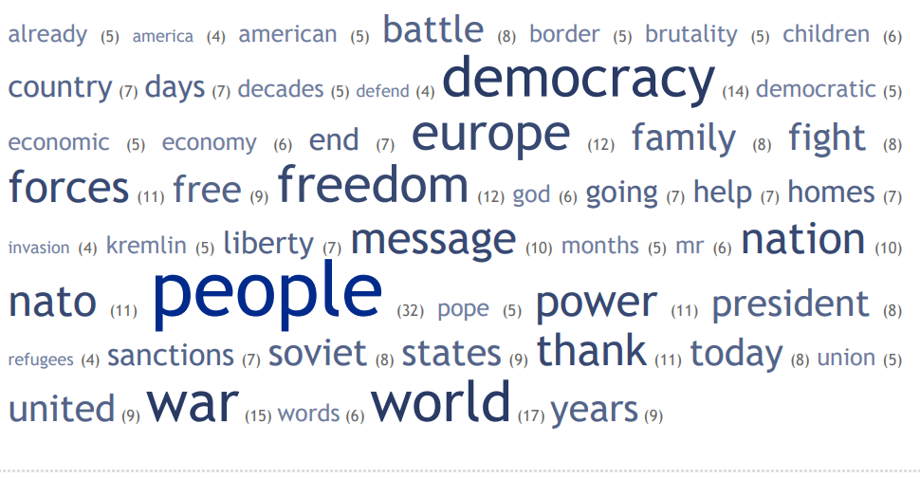
Graph 1. – Visual representation of the most used words in the March 26, 2022 Speech by President Joe Biden, Warsaw, Poland. Numbers of uses in parentheses.

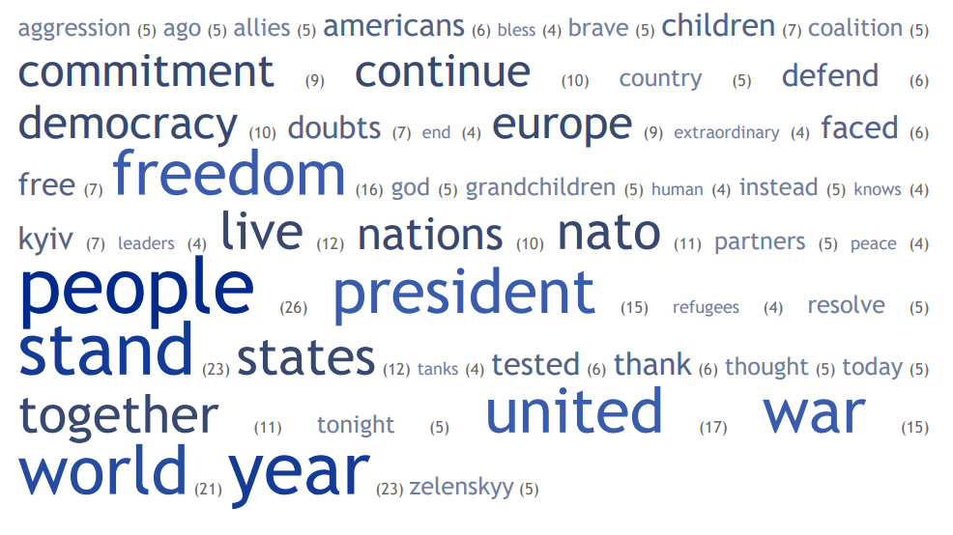
Graph 2. – Visual representation of the most used words in the February 21, 2023 Speech by President Joe Biden, Warsaw, Poland. Numbers of uses in parentheses.

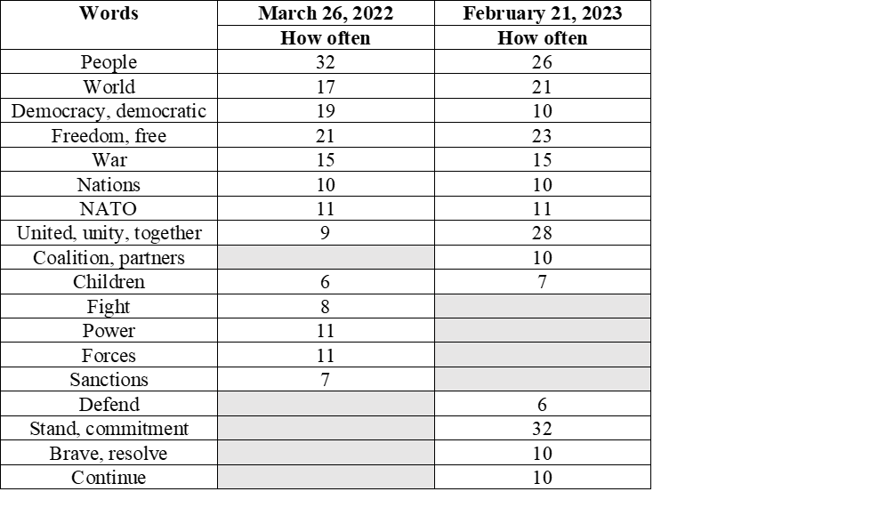
Graph 3 – Comparison between the most used words in both speeches.

The main theme of the first speech was “democracy”. In the second one the most powerful word was “freedom”, while “Ukraine will never be a victory for Russia” was a strong common thread for both. The comparison presented by Graph 3 is relevant for how some common themes were preserved or evolved. The idea of “unity”, expressed through multiple iterations (coalition, partners, together, allies) became the main feature of the second Warsaw speech, together with the commitment to continue to support Ukraine and the praise for the Ukrainian resolve. Some other issues of concern relevant to the beginning of the war (like sanctions, economy) were no longer addressed a year later, while new messages were used to portray where the war finds itself in February 2023 (“Ukraine stand, Kyiv stands).

US policies and support for Ukraine during the first year of war

Biden administration messages translated into an extensive set of policies ranging from military, humanitarian or energy security assistance, to imposing economic costs and extensive sanctions on Russia, building support at the UN and working in lockstep with the allies and partners.
According to the fact sheet provided by the White House on February 20, 2023, under the Biden administration, during the first year of war the US committed $30,4 billion in security assistance for Ukraine, from which $29.8 billion since the start of the war. This includes more than 8500 Javelins, over 1600 Stinger anti-aircraft system, 31 Abrams tanks, 45 T-72 tanks, 20 Mi-17 helicopters, 4000 Zuni aircraft rockets, 38 High Mobility Artillery Rocket Systems, 12 Avenger air defense system, millions of artillery rounds, one Patriot air defense battery and munitions, etc. (Fact Sheet on U.S. Security Assistance to Ukraine, February 20, 2023). On the humanitarian front, US provided more than $1.9 billion to Ukrainians, welcomed 267,000 Ukrainian refugees and created Uniting for Ukraine program. US also provided $340 million in refugee assistance to the European partners. (One Year Later: Helping Ukraine Win the War and Build Lasting Peace, February 2023).
On the energy security and economic assistance front, United States disbursed $13 billion in grant financing for budget support for Ukraine, provided electricity equipment to restore the power system, and, among other measures, through the US-EU Task Force on Energy Security US ensured that Europe had enough gas for the winter (FACT SHEET: One Year of Supporting Ukraine, February 21, 2023).
On March 20, 2023, the administration announced sending additional $350 million in military assistance, while Blinken emphasized the United States will continue to support Ukraine “for as long as it takes”. Overall, this leads up to $32 billion in lethal aid provided by the US. (Mitchell, 2023)

Conclusions and evaluations

The analysis of President’s Biden foreign policy speeches on Ukraine during the first year of war confirms a consistency between pre- and post-February 2022 messages, as well as throughout the entire first year since the Russian invasion.
Democracy has been Joe Biden’s most prominent theme both as a presidential candidate and as President, the core concept both in domestic politics and foreign policy, before the war and moreover after February 2022. Framing the war in Ukraine in terms of democracy vs. autocracy has encountered some criticism from US realist scholars in international relations (Is U.S. Foreign Policy Trying to Do Too Much? A Conversation with Emma Ashford, 2022), and some have considered that describing the war in terms of “sovereignty” could have provided a more “effective” framework. Nevertheless, “democracy” has remained a pillar of the presidential discourse, which matches the increasing relevance democracy has for the American public. While the second speech from Warsaw reveals an explicit increased focus on freedom and unity rather than democracy, the battle for democracy remains intrinsic to Biden’s foreign policy and domestic politics as well.
The analyzed speeches reveal the directions of the US foreign policy under the Biden administration in regard to Ukraine: a long-term commitment to support Ukraine defend itself against Russian aggression, framing the war inside of the bigger fight between democracy and autocracy, ensuring NATO unity and working in partnership with the allies. As time went by, President Biden had to continuously address both foreign and domestic concerns, including explaining why the support for Ukraine is in the national interest of the US and acknowledging the contribution of the American people and cost.
These messages were reinforced not only through the policies of the US administration, but through other political and symbolic actions. President Biden visited Ukraine at the one-year anniversary and visited Poland twice, which reflects the importance of Central and Eastern Europe under the current geopolitical context.
Given the consistency of the messages and actions so far, we can anticipate at this point that the Biden administration will continue with the same foreign policy directions and an unwavering support for Ukraine.

Literature

- Barnes, J. E., & Cooper, H. (2019, January 14). Trump Discussed Pulling U.S. From NATO, Aides Say Amid New Concerns Over Russia. The New York Times.
- Biden, J. R. (2020). Why America Must Lead Again. Rescuing Foreign Policy After Trump. Foreign Affairs, 99(2), 64-76.
- Detrow, S. (2020, December 30). Why Biden's National Security Adviser Plans to Focus on The US Middle Class. Retrieved from NPR: https://www.npr.org/sections/biden-transition-updates/2020/12/30/951280373/why-bidens-national-security-adviser-plans-to-focus-on-the-u-s-middle-class
- (February 20, 2023). Fact Sheet on U.S. Security Assistance to Ukraine. Department of Defense. Retrieved from https://media.defense.gov/2023/Feb/20/2003164184/-1/-1/0/UKRAINE-FACT-SHEET-PDA-32.PDF
- (February 21, 2023). FACT SHEET: One Year of Supporting Ukraine. White House. Retrieved from https://www.whitehouse.gov/briefing-room/statements-releases/2023/02/21/fact-sheet-one-year-of-supporting-ukraine/
- Garrity, K. (2023, February 27). Biden will back Ukraine for ‘as long as it takes,’ Yellen says in Kyiv. Retrieved from Politico: https://www.politico.com/news/2023/02/27/treasury-sec-trip-ukraine-00084557
- Haas, R. (2022, September 6). The Dangerous Decade. A Foreign Policy for a World in Crisis. Foreign Affairs, 101(5), 25-38.
- Is U.S. Foreign Policy Trying to Do Too Much? A Conversation with Emma Ashford. (2022, October 6). Foreign Affairs. Retrieved from https://www.foreignaffairs.com/podcasts/us-foreign-policy-trying-do-too-much
- Mitchell, E. (2023, March 20). US sending $350M in weapons, equipment to Ukraine in latest aid package. The Hill. Retrieved from https://thehill.com/policy/defense/3908806-us-sending-350m-in-weapons-equipment-to-ukraine-in-latest-aid-package/
- Montgomery, D. (2022, August 22). Can Antony Blinken Update Liberal Foreign Policy for a World Gone Mad? Inside the shaping and execution of the Biden-Blinken doctrine. Washington Post.
- (October 12, 2022). National Security Strategy. The White House, Washington. Retrieved from https://www.whitehouse.gov/wp-content/uploads/2022/10/Biden-Harris-Administrations-National-Security-Strategy-10.2022.pdf
- Neumann, I. B. (2008). Discourse Analysis. In A. Klotz, & D. Prakash (eds.), Qualitative Methods in International Relarions. A Pluralist Guide (pp. 61-77). New York: Palgrave Macmillan.
- (February 2023). One Year Later: Helping Ukraine Win the War and Build Lasting Peace. USAID. USAID. Retrieved from https://www.usaid.gov/news-information/fact-sheets/feb-2023-one-year-later-helping-ukraine-win-war-and-build-lasting-peace
- Remarks by President Biden Ahead of the One-Year Anniversary of Russia’s Brutal and Unprovoked Invasion of Ukraine, Warsaw, Poland. (2023, February 21). Retrieved from White House: https://www.whitehouse.gov/briefing-room/speeches-remarks/2023/02/21/remarks-by-president-biden-ahead-of-the-one-year-anniversary-of-russias-brutal-and-unprovoked-invasion-of-ukraine/
- Remarks by President Biden at the 2021 Virtual Munich Security Conference. (2021, February 19). Retrieved from White House: https://www.whitehouse.gov/briefing-room/speeches-remarks/2021/02/19/remarks-by-president-biden-at-the-2021-virtual-munich-security-conference/
- Remarks by President Biden Before Meeting with the Leaders of the Bucharest Nine. (2023, February 22). Retrieved from White House: https://www.whitehouse.gov/briefing-room/speeches-remarks/2023/02/22/remarks-by-president-biden-before-meeting-with-the-leaders-of-the-bucharest-nine/
- Remarks by President Biden in a Press Conference, Bali, Indonesia. (2022, November 14). Retrieved from White House: https://www.whitehouse.gov/briefing-room/speeches-remarks/2022/11/14/remarks-by-president-biden-in-a-press-conference-bali-indonesia/
- Remarks by President Biden in Press Conference, Madrid, Spain. (2022, June 30). Retrieved from White House: https://www.whitehouse.gov/briefing-room/speeches-remarks/2022/06/30/remarks-by-president-biden-in-press-conference-madrid-spain/
- Remarks by President Biden on Continued Support for Ukraine January 25, 2023. (2023, January 25). Retrieved from White House: https://www.whitehouse.gov/briefing-room/speeches-remarks/2023/01/25/remarks-by-president-biden-on-continued-support-for-ukraine/
- Remarks by President Biden on Russia’s Unprovoked and Unjustified Attack on Ukraine. (2022, February 24). Retrieved from White House: https://www.whitehouse.gov/briefing-room/speeches-remarks/2022/02/24/remarks-by-president-biden-on-russias-unprovoked-and-unjustified-attack-on-ukraine/
- Remarks by President Biden on the Assistance the United States is Providing to Ukraine. (2022, March 16). Retrieved from White House: https://www.whitehouse.gov/briefing-room/speeches-remarks/2022/03/16/remarks-by-president-biden-on-the-assistance-the-united-states-is-providing-to-ukraine/
- Remarks by President Biden on the Security Assistance to Ukraine, Lockheed Martin Pike County Operations. (2022, May 3). Retrieved from White House: https://www.whitehouse.gov/briefing-room/speeches-remarks/2022/05/03/remarks-by-president-biden-on-the-security-assistance-to-ukraine/
- Remarks by President Biden on the United Efforts of the Free World to Support the People of Ukraine, Warsaw, Poland. (2022, March 26). Retrieved from White House: https://www.whitehouse.gov/briefing-room/speeches-remarks/2022/03/26/remarks-by-president-biden-on-the-united-efforts-of-the-free-world-to-support-the-people-of-ukraine/
- Reynolds, M. (2022, October 17). Fiona Hill: ‘Elon Musk Is Transmitting a Message for Putin’. Politico Magazine. Retrieved from https://www.politico.com/news/magazine/2022/10/17/fiona-hill-putin-war-00061894
- State of the Union Address 2022. (2022, March 1). Retrieved from White House: https://www.whitehouse.gov/state-of-the-union-2022/

Richard Haas is a well-known diplomat and specialist in international relations, President of the prestigious US think tank Council on Foreign Relations.
Readouts and statements on calls with President Zelenskyy – October 10, October 4, Aug 25, June 15, April 13, March 30, March 11, March 5, Mar 1, Feb 24, Feb 21.
For further reference, these are exact messages from the 2022 State of the Union: “(Putin) thought the West and NATO wouldn’t respond. He thought he could divide us at home, in this chamber, in this nation. He thought he could divide us in Europe as well. But Putin was wrong. We are ready. We are united. And that’s what we did: We stayed united.” “But let me be clear: Our forces are not engaged and will not engage in the conflict with Russian forces in Ukraine. Our forces are not going to Europe to fight [in] Ukraine but to defend our NATO Allies in the event that Putin decides to keep moving west.” “And as I’ve made crystal clear, the United States and our Allies will defend every inch of territory that is NATO territory with the full force of our collective power — every single inch.” “In the battle between democracy and autocracies, democracies are rising to the moment and the world is clearly choosing the side of peace and security.”
https://tagcrowd.com/
The future of democracy was a significant issue for the American voters during the November 2022 midterm elections. A Pew Research poll from October 2022 indicated that 70% of the voters considered the future of democracy important for their vote. https://www.pewresearch.org/politics/2022/10/20/the-midterm-elections-and-views-of-biden/

