Civil society as the arena of the new European climate hegemony. A neo-Gramscian approach to European green transition.

Abstract
Using a neo-Gramscian approach, this paper explores the concept of civil society as an arena where European climate hegemony is built. The EU’s green transition, which involves deep social and economic transformations, needs extensive popular support to avoid social instability and the rise of populist parties. To achieve this, the European Commission is trying to construct a counter-hegemonic discourse that challenges the traditional modes of a fossil fuel-based economy by creating an alliance of actors around the ideology of just transition. Therefore, the study addresses the following research question: who are the change agents within European civil society that have aligned with the alliance and how is fostering a counter-hegemonic discourse against the traditional economic model? By employing a qualitative methodological approach, the study explores the crucial function of civil society in the European green transition, exposing how these agents facilitate the formation of a new climate hegemony.
Keywords: change actors, civil society, European integration, green transition, hegemony.

Mihail Caradaica, born in 1987 in Pogoanele, Buzau County, Romania, is a University Lecturer at the National University of Political Studies and Public Administration (SNSPA) in Bucharest. As a professor, he imparts knowledge of European studies, sustainable development, and integrating new technologies in environmental conservation. His scholarly contributions include publications on the neoliberal era in the European Union, the process of globalisation, and the ideological spectrum of European integration. He works also as the Executive Director of the Tomorrow’s Forest Foundation and is a passionate advocate for environmental conservation and sustainable development.
E-mail: mihai.caradaica@dri.snspa.ro
Mobile phone: +40720906425

Introduction
The relationship between the European Union and its emerging civil society has always been the subject of academic debates. As civil society was naturally built at the national level, the European construction process developed ways for European civil society to take shape. From the first election for the European Parliament that took place in 1979 to the Lisbon Treaty that provided a tool for participatory democracy called the European Citizens’ Initiative (Sasvari 2015), the goals of European Platforms and Networks of NGOs were to impact the direction of the European Union’s actions and development by highlighting the needs and ambitions of their clientele (Dirk 2012). Nowadays, as the effects of the European Green Deal (EGD) are impacting European society, the role of the organised European civil society will be to balance the ambitious climate goals with social fairness and inclusivity.
The need for protective social policies that should come together with the green transition (Zimmermann and Gengnagel 2023) emphasises the role of the Platforms and Networks of NGOs in influencing the EGD by advocating for inclusive policies that took into consideration the needs of the European citizens and vulnerable communities, ensuring that no one is left behind (Pianta and Lucchese 2020: 6). Vulnerable European citizens could turn supporting populist parties and climate sceptical political leaders may slow down the green transition (Thalberg et al. 2024; Stegemann and Ossewaarde 2018). However, the role of the organised European civil society is not just to provide feedback for EU institutions in drafting new policies but also to ensure that a consensus for the green transition is reached between European citizens.

Literature review
This research uses a critical approach that will provide the theoretical framework to understand the complex relations between social forces shaping European policies and the role of civil society. The neo-Gramscian theory, rooted in the ideas of the Italian philosopher Antonio Gramsci, focuses on the European integration process, stating that it is a project driven by dominant economic groups’ interests by concepts like hegemony, social forces, civil society, or organic intellectuals. For example, Andreas Bieler (2005) suggests that neo-Gramscianism, using the concept of class struggle, provides deep insights into how the socio-economic agenda shapes European policies. Harald Köpping Athanasopoulos (2020) sees European integration as part of the global neoliberal hegemony where international capital benefits from this process in front of the broader societal interests. In this case, European integration is more than a process; it is assimilated with a hegemonic project that shapes social relations and public policies in favour of the elite interests. Bieler and Morton (2001) and Apeldoorn (2004) emphasised how neo-Gramscian theory has been applied to understand hegemony and structural changes in the European Union, while Levy and Egan (2003) explored how neo-Gramscian framework can be applied to corporate strategies, highlighting the intersection of capital, social forces, and state policies in environmental negotiations and providing an explanation on how European integration process is shaped by the corporate interests through regulatory frameworks.
Neo-Gramscian analysis views European integration as a political project that impacts all facets of EU social norms and identities, including economic policy, by acting as a transnational vehicle for capitalist hegemony. However, the EGD and the transition to a Net Zero society require a new hegemonic project to be shaped. At this point, Harald Winkler adapts the neo-Gramscian theory to understand the just transition process to a green European society. He applies and modifies some core concepts of Grasmci’s thought, such as ideology, hegemony, change agents, and fundamental conditions to articulate a theory that understands just transition as an ideological element that will bring together coalitions of change agents (Winkler 2020: 1). The role of the change agents (such as labour unions, NGO Networks, social movements, governments, businesses, or international organisations) is basically to form an alliance and to reinforce a new cultural hegemony that supports moving away from high-carbon and inequality-driven economy (Winkler 2020: 8).
The concept of hegemony provided by neo-Gramscian theory allows the research to go beyond the traditional Marxist mechanisms of power in society. The relevance of Gramsci’s concept of hegemony is particularly important today in the context of globalisation and the dominance of neoliberal ideologies (Johnson 2007: 102–6), shaping the hegemonic model known as fossil capitalism (Huber 2009; Griffiths 2023). According to Cader and Sundrijo (2023) and Caradaica (2013), hegemony involves a more critical role of cultural and ideological factors over coercive power in constructing the people’s collective will. This is how the dominant classes maintain their leadership, creating common sense and projecting their interest as universal.
The contestation of the hegemonic fossil capitalism conducted by the change agents takes place in civil society. In the neo-Gramscian approaches, civil society is understood as a social realm that can drive social transformation and as a site where “hegemony is consented, sustained, reproduced and channelled, but also where counter-hegemonic and emancipatory forces also could emerge” (Icaza Garza 2006: 488). Therefore, civil society is more a relational concept, where the hegemonic project is maintained or changed through consent rather than coercion (Rupert 1998: 431). As coercion is a feature of the national state, European Union lacks this way of social intervention.
Going deeper into Antonio Gramsci’s political thinking, one can also find organic intellectuals who can be identified as change agents. The concept of organic intellectuals in neo-Gramscian theory positions specific individuals as crucial drivers in forming and maintaining a hegemonic structure. A simple definition is that organic intellectuals exercise leadership by organising social hegemony (Evans 2005). In contrast with traditional intellectuals, who have their roots in a previous mode of production and continue to maintain their sphere of influence and structure in a context of significant changes in production and political and social organisation (Silva 2022), organic intellectuals are deeply rooted in the structure of the class and actively contribute to shaping the direction and consciousness of their respective classes (Pijl 2005). Gramsci explains the identity of the organic intellectuals by stating that everyone has the potential to be an intellectual, even if not everyone fulfils the social role of an intellectual (Gramsci 1971). Therefore, organic intellectuals will be part of the change agents’ concept that can contribute to the new European climate hegemony.
To conclude, according to the neo-Gramscian theory, civil society is an arena where the contestation of the fossil capitalist hegemonic model takes place, while a new European climate hegemony of just transition may arise conducted by the change agents that joined the alliance, such as organic intellectuals, labour unions, NGO Networks, social movements, governments, businesses, or international organisations. At this point, the research question of this paper is formulated as follows: “Who are the change agents within European civil society that have aligned with the alliance and how fostering a counter-hegemonic discourse against the traditional economic model?”.

Methodology
To answer the research question, this paper will employ qualitative content analysis to understand the commitment of the change agents in the transition process to a Net Zero economy. To achieve this, the change agents will be split into three categories: individuals (Climate Pact Ambassadors), organisations (NGOs, Networks of NGOs, movements, labour unions, political organisations) and private companies. The description, action plans, or public profiles of change agents will be examined using the qualitative content analysis method after an in-depth and structured process of coding and categorising textual data to find patterns, themes, and meanings. This method involves collecting data from official websites like the European Climate Pact (‘Meet Our Ambassadors’, n.d.), where the profiles of 884 Climate Ambassadors are available as the research is performed in March 2024, or individual websites of all 43 organisations that joined the Alliance for Just Transition (‘European Alliance for a Just Transition -’, n.d.) until March 2024. The results will be assessed using neo-Gramscianism as a critical theory of understanding the European integration process to emphasise the role of the change agents in promoting a just transition to a new European climate hegemony using civil society as an arena for contesting the present hegemonic structure of fossil capitalism.

Analysis
The neo-Gramscian definition of civil society, as a realm where the formation of a new hegemonic project takes place, allows us to go beyond the traditional definition of civil society and to identify all the active actors in promoting a just transition. Therefore, for a better overview of European civil society that is now part of the alliance for a green transition initiated and maintained by the European Commission, all the change agents will be split into three different categories: individuals, NGOs (organisations, movements, networks, or political parties), and businesses.
Regarding individual involvement, the most prominent role belongs to European Climate Pact Ambassadors (CPAs). They are key figures in the consensus-building process initiated by the European Commission and act on a voluntary base at the national and supranational levels. The European Climate Pact is a tool of the European Green Deal aiming to engage individuals, communities, and organisations in climate change mitigation activities and promoting sustainable development. The role of the ambassadors is to inform, inspire and support climate actions within their networks and communities (‘Become a Pact Ambassador’, n.d.). According to Jale Tosun, CPAs are crucial in promoting participatory governance and are a crucial component of the European Union’s strategy for transitioning to sustainable development. The European Green Deal’s ambitious objective requires CPAs to play a crucial role in this transformation (Tosun 2022). They were selected based on their steadfast dedication to climate action, and in order to maximise the impact of their climate advocacy, they must set an outstanding example, motivate others, and cultivate relationships (Tosun, Pollex, and Crumbie, 2023).
In another comprehensive study, Jale Tuson, Lucas Geese, and Irene Lorenzoni evaluated CPA profiles to determine how committed these individuals are to taking climate action. They discovered that CPAs represent both older and younger generations and that their perspectives on advocating for climate action can vary significantly. Older participants usually mention their worry for future generations as a significant incentive, whereas younger ambassadors are more likely to directly include their peers in climate projects (Tosun, Geese, and Lorenzoni, 2023). Nevertheless, the role of the ambassadors and their commitments will not make them genuine organic intellectuals in a Gramscian way unless they are not representative of their environment and they are not performing a variety of activities related to climate change. At this point, the qualitative content analysis conducted on the public profiles of the CPAs (‘Meet Our Ambassadors’, n.d.) shows that the distribution of the ambassadors in national states is as follows: Italy - 13.49 per cent, Spain - 12.06 per cent, Germany - 8.66 per cent, France - 7.68 per cent, Greece - 5.92 per cent, Belgium - 5.92 per cent, Netherlands - 4.50 per cent, Poland - 4.28 per cent, Portugal - 4.28 per cent, Romania - 3.40 per cent, Bulgaria - 2.74 per cent, Luxembourg - 2.63 per cent, Austria - 2.52 per cent, Hungary - 2.30 per cent, Sweden - 2.19 per cent, Ireland - 2.19 per cent, Slovakia - 2.08 per cent, Lithuania - 2.08 per cent, Czech Republic - 2.08 per cent, Croatia - 1.54 per cent, Finland - 1.43 per cent, Latvia - 1.43 per cent, Slovenia - 1.32 per cent, Denmark - 1.10 per cent, Estonia - 0.77 per cent, Cyprus - 0.77 per cent, Malta - 0.66 per cent. This distribution shows a fair distribution where the most populated EU states have higher percentages regarding the number of ambassadors, while the small states have fewer.
Besides representativeness, the variety of activities that ambassadors conduct is also crucial because it shows the diversity of the social sector where they act. The qualitative content analysis on their public profiles and focused on critical words regarding their commitments and activities revealed the following results: Awareness: 27.38 per cent, Sustainability: 19.37 per cent, Energy: 13.89 per cent, Education: 13.29 per cent, Research: 10.65 per cent, Policy: 7.40 per cent, Transport: 3.65 per cent, Advocacy: 2.23 per cent, Conservation: 1.42 per cent, Waste Management: 0.71 per cent, as Figure 1 shows. Therefore, all these categories can be split into three activities: Education and raising awareness, sustainable practices and research, and public policy advocacy. Summing up, 40.67 per cent of the ambassadors mentioned rising awareness and education as their main activities for 2024, which means that they will participate in public events, draft formal education courses for the curriculum, or undergo training sessions. Through these activities, they will spread the European message regarding climate change and a just transition to a green economy and try to reach a consensus among regular citizens. 30.02 per cent of them will promote sustainable practices among individuals, businesses, and member states using research tools and good practices models. 29.3 per cent of the ambassadors are focused on public policy advocacy and are active in climate change-related sectors like energy, transport, nature conservation, and waste management.
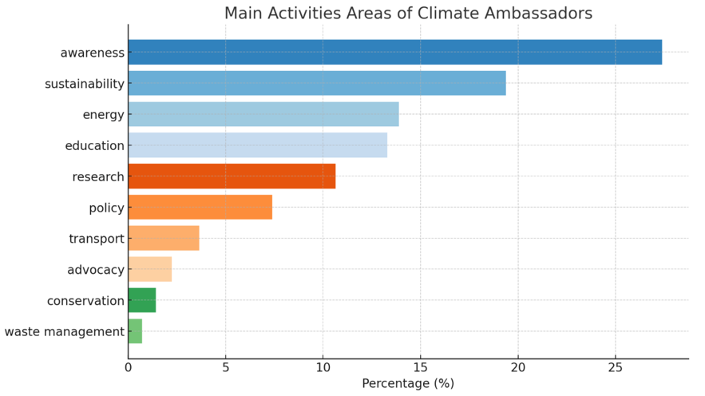
Figure 1 (author’s contribution)

Another category of change agents vital for building a new hegemonic project in the civil society arena are organisations such as non-governmental organisations, movements, networks, or political parties. For a clear picture of the organisations that are actively promoting the European message of just transition, the paper will focus on the analysis of the European Alliance for a Just Transition, an informal group of organisations that share a common vision for a Just Transition to a social and sustainable Europe (‘European Alliance for a Just Transition -’, n.d.). The forty-three members of this alliance were analysed based on the type of organisation, activity area, description, strategic vision, and number of members (if it was a network of organisations from EU member states). The qualitative content analysis conducted on all the information gathered about these organisations shows that 41.86 per cent of them are Networks of NGOs, 18.60 per cent are Political Organisations, 18.60 per cent are NGOs, 9.30 per cent are Think Tanks, 9.30 per cent are Advocacy Groups, 2.33 per cent are Union Federations (see Figure 2). Furthermore, only 25.58 per cent represent environmental organisations, 55.82 per cent represent other social causes (women’s rights, people with disabilities, education, fight against poverty or democracy), and 18,60 per cent represent political causes.
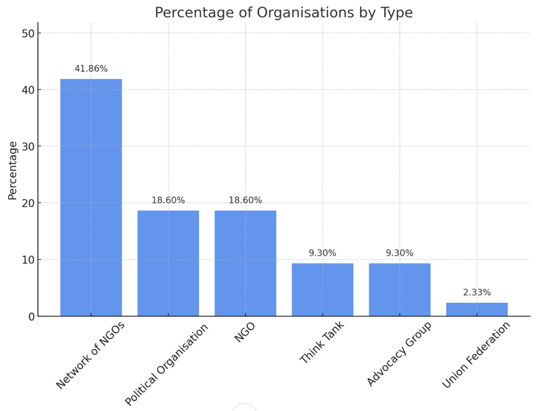
Figure 2 (author’s contribution)

Because environmental organisations are already familiar with climate change, climate action, pollution, circular economy, reforestation and afforestation, environmental protection, waste management or carbon footprint, the question is how many other organisations incorporated the climate fight into their activities? According to qualitative research, 62.5 per cent of the organisations listed online that do not have “Environment” as their activity area still contain environmental activities in their descriptions or strategic visions. According to Figure 3, the impact of joining the European Alliance for a Just Transition can be seen in the distribution of precents between descriptions or strategic visions while only 31,25 per cent of them have environmental activities in the description, while 59,38 per cent in the strategic vision. It shows a process of adaptation and reorientation toward green activities. Another relevant aspect is that, of the forty-three members of this alliance, approximately 55 per cent mention either “just transition” or “climate justice” in their descriptions or strategic visions, making them more reliant on the hegemonic project of the European Union.
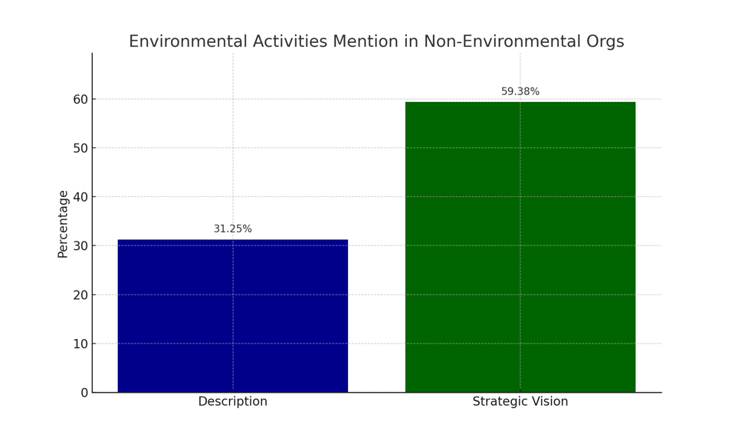
Figure 3 (author’s contribution)

The last category discussed in this paper, as part of the concept of European civil society from the neo-Gramscian perspective, is private companies. Their transformative role should not be neglected, as the European Commission is asking them to get more involved in the green transition process and to support NGOs through CSR activities. However, at this moment, no formal alliance was established yet, as in September 2022, CSR Europe, together with the EU Commissioner for Jobs and Social Rights, Nicolas Schmit, and CEOs of leading companies met in Brussels to initiate a broader EU Business Alliance for Just Transition (‘Business Leaders Join Forces with the Commission for an Inclusive Green Deal’ 2022). When the alliance is established, an in-depth analysis can be conducted also on private companies.

Conclusions
This paper explores the role of civil society, understood through the neo-Gramscian lens, as a critical arena for contesting the hegemonic project of the fossil fuel-based economic paradigm and cultivating a counter-hegemonic discourse. The new European climate hegemony, based on the ideology of a just transition to a green economy, aims to gain popular support for the transition policies, mitigating the risk of social instability and the ascendancy of populist factions. Therefore, the research explicitly addresses these change agents within European civil society by employing a qualitative methodology to identify the relevant actors and analyse their relevance and potential impact. Findings indicate that change agents could be identified across individuals, organisations (NGOs, networks, movements, labour unions, political organisations), and private companies.
Regarding individuals, the most representative change actors identified are the European Climate Pact Ambassadors. They are key figures in the consensus-building process, acting voluntarily and aiming to engage individuals, communities, and organisations in climate change mitigation activities and promoting sustainable development. The 884 Climate Ambassadors profile analysis shows good representativeness at each member state and various areas they are willing to engage in during the mandate. Most ambassadors, around 40 per cent, are engaged in activities like raising awareness and education, which accurately overlap to build consensus; a third of them is promoting sustainable practices among individuals, businesses, and member states, while the other third is focused on public policy advocacy being active in climate change related sectors like energy, transport, nature conservation and waste management.
Regarding the analysis conducted on the organisations that joined the European Alliance for a Just Transition, it shows a dominance of NGOs, networks of NGOs and political organisations that are adapting their discourse and strategic vision to climate-related topics, while more than half of all members were mentioning “just transition” or “climate justice” in their descriptions or strategic visions. After excluding about 25 per cent of these organisations from analysis because they are already involved in environmental activities, the paper reveal that 31,25 per cent of them already mentioned environmental activities in their description while 59,38 per cent were updating the strategic vision for future actions. The private companies that could be essential change agents are not yet constituted in a formal alliance, as the process started in September 2022. Climate topics are now part of the CSR activities of individual companies.
Answering the research question of this paper, who are the change agents within European civil society that have aligned with the alliance and how fostering a counter-hegemonic discourse against the traditional economic model, the study showed that the most significant change agents are Climate Pact Ambassadors as individual acting on a volunteer base and perform a variety of activities, and different type of organisations that joined the European Alliance for a Just Transition and that are adapting discourse and strategic vision to climate-related topics. The way these change actors are fostering a counter-hegemonic discourse is diverse. CPAs use their national or local influence and recognition to engage people, while the organisations analysed use public and private funds to perform their activities.

Literature

- Apeldoorn, Bastiaan van (2004): ‘Theorising the Transnational: A Historical Materialist Approach’. Journal of International Relations and Development 7 (2): 142–76. https://doi.org/10.1057/palgrave.jird.1800010.
- ‘Become a Pact Ambassador’ (n.d): Accessed 17 March 2024. https://climate-pact.europa.eu/get-involved/become-pact-ambassador_en.
- Bieler, Andreas (2005): ‘European Integration and the Transnational Restructuring of Social Relations: The Emergence of Labour as a Regional Actor?*’. JCMS: Journal of Common Market Studies 43 (3): 461–84. https://doi.org/10.1111/j.0021-9886.2005.00565.x.
- Bieler, Andreas, and Adam David Morton (2001): ‘The Gordian Knot of Agency—Structure in International Relations:: A Neo-Gramscian Perspective’. European Journal of International Relations 7 (1): 5–35. https://doi.org/10.1177/1354066101007001001.
- ‘Business Leaders Join Forces with the Commission for and Inclusive Green Deal’ (2022): CSR Europe. 22 August 2022. https://www.csreurope.org/newsbundle-articles/business-leaders-join-forces-with-the-commission-for-and-inclusive-green-deal.
- Cader, Indira Thalia, and Dwi Ardhanariswari Sundrijo (2023): ‘Critical Analysis of Neo-Gramscian Hegemony’. Eduvest - Journal of Universal Studies 3 (8): 1435–48. https://doi.org/10.59188/eduvest.v3i8.894.
- Caradaică, Mihail (2013): ‘European Union in the Age of Neo-Liberalism’. EUROPOLITY 7 (1): 21–33.
- Dirk, Jarre (2012): ‘Civil Society in the European Union’. Civil Szemle 9 (1).
- ‘European Alliance for a Just Transition -’ (n.d): European Alliance for a Just Transition. Accessed 10 March 2024. https://alliancejusttransition.eu/.
- Evans, Bryan (2005): ‘How the State Changes Its Mind: A Gramscian Account of Ontario’s Managerial Culture Change’. Philosophy of Management 5 (2): 25–46. https://doi.org/10.5840/pom20055220.
- Gramsci, Antonio (1971): ‘“The Intellectuals”, in Selections from the Prison Notebooks’. 1971. https://www.marxists.org/archive/gramsci/prison_notebooks/problems/intellectuals.htm.
- Griffiths, Michael (2023): ‘From Fossil Capitalism to Climate Capitalism: Contemporary Systems for Capitalist Accumulation and Incremental Climate Action’. Political Science Undergraduate Review 8 (1). https://doi.org/10.29173/psur345.
- Huber, Matthew T. (2009): ‘Energising Historical Materialism: Fossil Fuels, Space and the Capitalist Mode of Production’. Geoforum, Themed Issue: Postcoloniality, Responsibility and Care, 40 (1): 105–15. https://doi.org/10.1016/j.geoforum.2008.08.004.
- Icaza Garza, Rosalba (2006): ‘To Be and Not to Be: The Question of Transborder Civic Activism and Regionalization in Mexico. A Critical Account of Neo-Gramscian Perspectives’. Globalizations 3 (4): 485–506. https://doi.org/10.1080/14747730601022461.
- Johnson, Richard (2007): ‘Post-Hegemony?: I Don’t Think So’. Theory, Culture & Society 24 (3): 95–110. https://doi.org/10.1177/0263276407075958.
- Köpping Athanasopoulos, Harald (2020): ‘Thinking Europe Differently – Critical Approaches to European Integration’. In EU Migration Management and the Social Purpose of European Integration: The Spillover of Misery, edited by Harald Köpping Athanasopoulos, 43–64. IMISCOE Research Series. Cham: Springer International Publishing. https://doi.org/10.1007/978-3-030-42040-6_3.
- Levy, David L., and Daniel Egan (2003): ‘A Neo-Gramscian Approach to Corporate Political Strategy: Conflict and Accommodation in the Climate Change Negotiations*’. Journal of Management Studies 40 (4): 803–29. https://doi.org/10.1111/1467-6486.00361.
- ‘Meet Our Ambassadors’ (n.d): Accessed 17 February 2024. https://climate-pact.europa.eu/get-involved/meet-our-ambassadors_en.
- Pianta, Mario, and Matteo Lucchese (2020): ‘Rethinking the European Green Deal: An Industrial Policy for a Just Transition in Europe’. Review of Radical Political Economics 52 (4): 633–41. https://doi.org/10.1177/0486613420938207.
- Pijl, Kees van der (2005): ‘Gramsci and Left Managerialism’. Critical Review of International Social and Political Philosophy 8 (4): 499–511. https://doi.org/10.1080/13698230500205169.
- Rupert, Mark (1998): ‘(Re-)Engaging Gramsci: A Response to Germain and Kenny’. Review of International Studies 24 (3): 427–34. https://doi.org/10.1017/S0260210598004276.
- Sasvari, Nora (2015): ‘How Does the European Citizens’ Initiative Help Partcipation in EU Affairs?’ Civil Szemle 12 (1).
- Silva, Deise Rosalio (2022): ‘Gramsci and Intellectuals, from Organic to Lorian: A Facet to Think about Bolsonarism’. Educação Em Revista 38 (December): e39479. https://doi.org/10.1590/0102-4698368539479T.
- Stegemann, Laura, and Marinus Ossewaarde (2018): ‘A Sustainable Myth: A Neo-Gramscian Perspective on the Populist and Post-Truth Tendencies of the European Green Growth Discourse’. Energy Research & Social Science, Sustainable energy transformations in an age of populism, post-truth politics, and local resistance, 43 (September): 25–32. https://doi.org/10.1016/j.erss.2018.05.015.
- Thalberg, Karin, Camille Defard, Thierry Chopin, Alicia Barbas, and Klervi Kerneis (2024): ‘The European Green Deal in the Face of Rising Radical Right-Wing Populism’. Policy Paper, no. 296. https://institutdelors.eu/en/publications/the-european-green-deal-in-the-face-of-rising-radical-right-wing-populism/.
- Tosun, Jale (2022): ‘What Role for Climate Pact Ambassadors? A Policy Process Perspective’. European View 21 (2): 171–77. https://doi.org/10.1177/17816858221128719.
- Tosun, Jale, Lucas Geese, and Irene Lorenzoni (2023): ‘For Young and Future Generations? Insights from the Web Profiles of European Climate Pact Ambassadors’. European Journal of Risk Regulation 14 (4): 747–59. https://doi.org/10.1017/err.2023.53.
- Tosun, Jale, Jan Pollex, and Laurence Crumbie (2023): ‘European Climate Pact Citizen Volunteers: Strategies for Deepening Engagement and Impact’. Policy Design and Practice 6 (3): 344–56. https://doi.org/10.1080/25741292.2023.2199961.
- Winkler, Harald (2020): ‘Towards a Theory of Just Transition: A Neo-Gramscian Understanding of How to Shift Development Pathways to Zero Poverty and Zero Carbon.’ Energy Research and Social Science 70: 101789. https://doi.org/10.1016/j.erss.2020.101789.
- Zimmermann, Katharina, and Vincent Gengnagel (2023): ‘Mapping the Social Dimension of the European Green Deal’. European Journal of Social Security 25 (4): 523–44. https://doi.org/10.1177/13882627231208698.

